Тема № 2

The Republic Of Belarus

Тематический словарь
amalgamation [ә/mәlgә/mei∫n] объединение
border(on) [/bo:dә] граничить с
coal [koul] уголь
constitute [/konstitju:t] составлять, образовывать
cover [/k٨vә] покрывать
crop [krop] сельхозкультура, урожай
deposits [di/pozits] залежи, месторождения; mineral deposits (залежи полезных ископаемых).
despite [dis/pаit] несмотря на
enterprise [/entәprаiz] предприятие
fertilizer [/fә:tilаizә] удобрение
flax [flәks] лён
iron [aiәn] железо
lose [lu:z] (lost) терять, лишаться
moderately [/modәritli] умеренно
non-ferrous [/non/ferәs] цветной (металл)
plain [plein] равнина
potash [/potә∫] поташ, углекислый калий
restore [ris/to:] восстанавливать
suffer [/s٨fә] страдать, мучиться
wealth [welӨ] богатство

The Republic Of Belarus
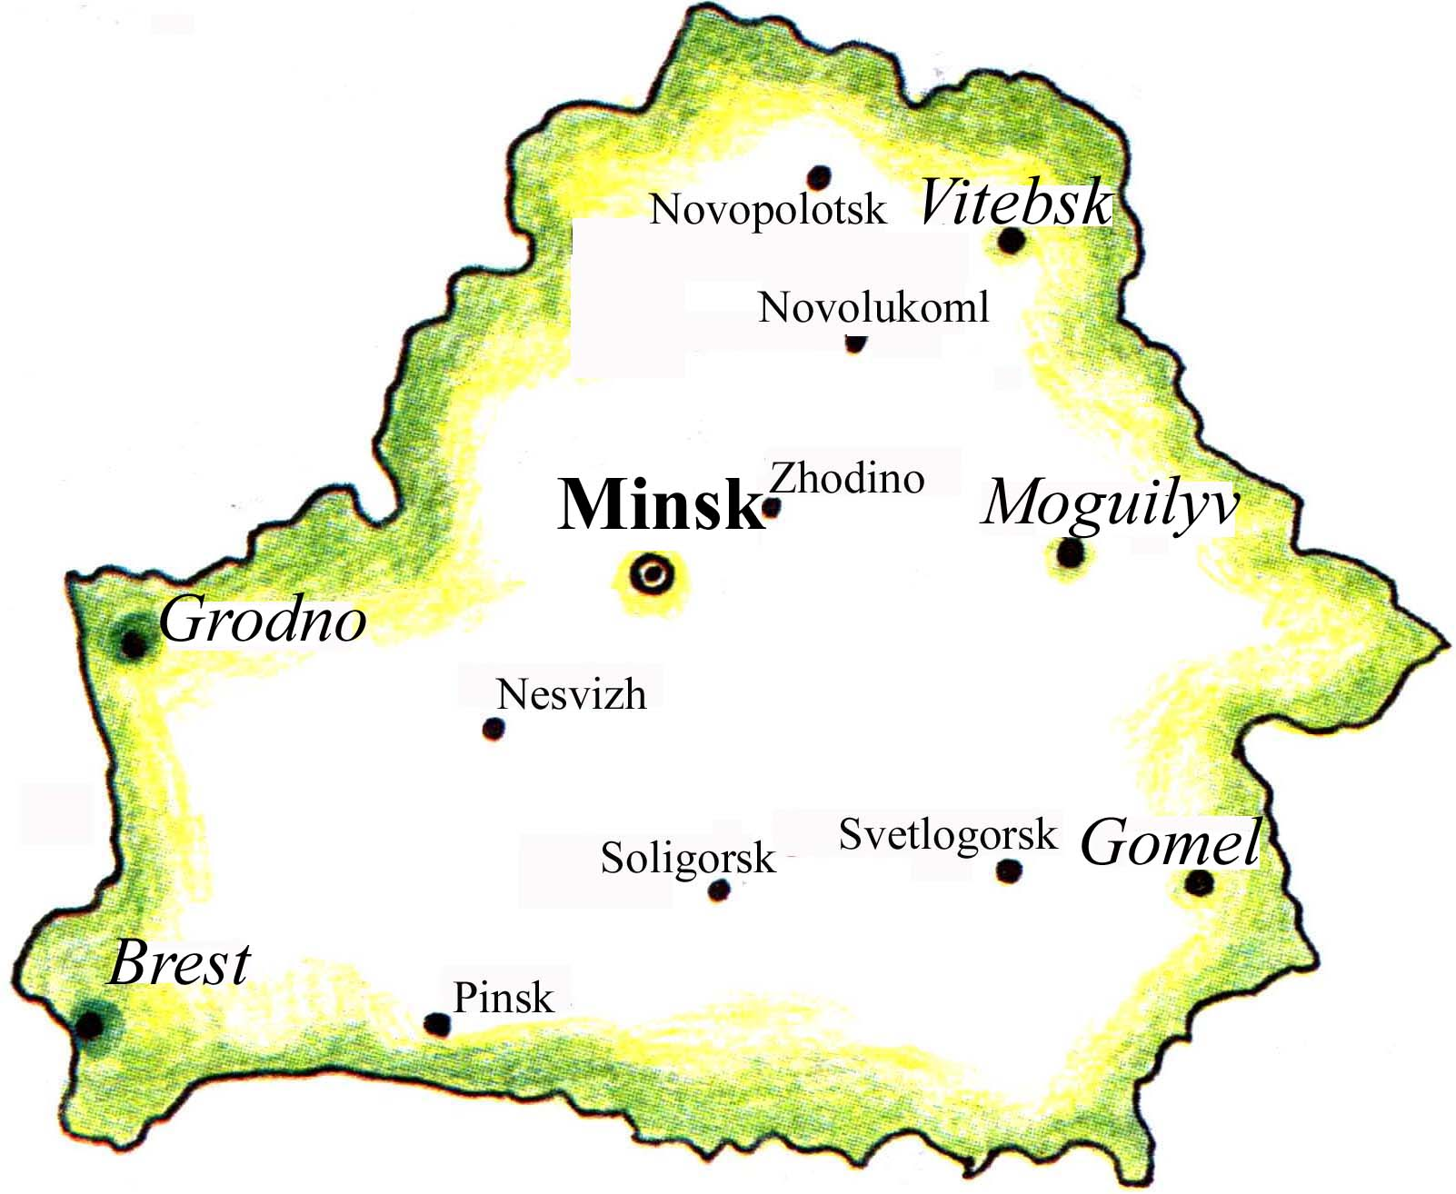
The Republic of Belarus is situated in Eastern Europe. It borders on Russia, the Ukraine, Poland, Lithuania and Latvia. The republic consists of six regions: Minsk, Brest, Grodno, Gomel, Moguilyov and Vitebsk. Minsk is the capital of Belarus. The territory of the Republic of Belarus is 207.600 square kilometres. The population is about 10 million. The Belarusians constitute 77 per cent of the population.
Belarus is a broad plain. One third of its territory is covered with forests. They have rich flora and fauna. There are 20.000 rivers in the country. The longest rivers are the Dnieper,the Nieman, the Western Dvina, the Pripyat and the Bug. There are 10.000 lakes in Belarus. The largest lake is the Naroch. The climate of the country is moderately continental.
Belarus is rich in mineral deposits: potash, rock-salt, coal, iron-ore, bauxite, non-ferrous and rare metals, etc. Belarusian industry produces tractors, big lorries, automatic lines, computers, refrigerators, television sets, bicycles, watches, fertilizers and textiles. The biggest enterprises in the republic are the automobile plants in Minsk and Zhodino, the tractor plant in Minsk, the production amalgamation “Azot” in Grodno.
Agriculture specializes in milk and meat production. The main crops cultivated in the country are grain, potatoes, flax and vegetables.
Belarus is a country of well developed science and culture. We have a lot of historical monuments, museums, theaters. There are many schools and higher educational establishments in the republic.
The Republic of Belarus is a sovereign independent state. The head of the state is the President. Belarus is a member of the United Nations and other international organizations.

