Approved at the meeting of Economic theory
2020.09.01, protocol № 1

Questions for an exam
on discipline "Macroeconomic analysis and policy"
Theoretical part.
- Macroeconomic problems of science. Long-term economic growth. Business cycles. Unemployment. Inflation. Foreign trade balance. Macroeconomicpolicies.
- Macroeconomic analysis. Macroeconomic studies. Macroeconomic forecasting.
- Economic schools. Neoclassical macroeconomic model. Keynesianism. Keynesian-neoclassical synthesis. Monetarism. "NewClassics". "NewKeynesians."
- Historical conditions and assumptions of the neoclassical model.
- The real sector in the neoclassical model.
- General economic equilibrium in the real sector. Walras law for macro markets and disequilibrium.
- The financial sector in the neoclassical model.
- General economic equilibrium in the neoclassical model.
- Neoclassical macroeconomic model for an open economy with the public sector.
- The Great Depression and the crisis of the neo-classical theory.
- Historical conditions of the origin and background of the Keynesian model.
- Keynesian model of the real sector. The equilibrium in the real sector of the Keynesian model.
- Keynesian theory of the cycle.
- Fiscal policy in the Keynesian model.
- Keynesian model of monetary sector. Portfolio theory of demand for money. Themoneysupply.
- Equilibrium in financial markets.
- Monetary policy in the Keynesian model.
- Joint equilibrium commodity and monetary sectors. IS-LM model. Analytical and graphical interpretation of the Keynesian general equilibrium model.
- Countercyclical policy in IS-LM model.
- Keynesian model of economic growth.
- The origin and background of the neoclassical synthesis.
- The aggregate demand for goods market. Microeconomic foundations of the real sector: household consumption, investment demand, the labor market.
- Aggregate supply. Aggregate supply relationship with inflation, expected inflation and unemployment.
- Monetary sector neoclassic synthesis. Long-term and short-term neutrality of the non-neutrality of money.
- Macroeconomic policy in an open economy with a fixed exchange rate in conditions of high and low capital mobility.
- Macroeconomic policy in an open economy with a floating exchange rate f in high and low capital mobility.
- The reasons for the appearance and characteristics of the monetarist model.
- The real sector in the monetarist model. Short- and long-term equilibrium in the real sector of the monetarist model
- The financial sector in the monetarist model. The demand for money. The money supply. Theequilibriumofthe money market.
- The overall economic balance in the monetarist model.
- State stabilization policy in an economy with adaptive expectations.
- Monetary policy in the monetarist model. Monetaryrule.
- Fiscal policy in the monetarist model, and its effectiveness.
- The formation of an inflationary spiral. The development of inflation as a result of a single monetary shock. development of inflation at a steady pace of money supply growth.
- Monetarist idea of ​​the business cycle.
- Historical conditions for the appearance of a macroeconomic model of the "new classics".
- The hypothesis of rational expectations. "Criticism" Lucas.
- The labor market in the economy with rational expectations.
- Aggregate supply in the economy with rational expectations.
- Aggregate demand in a macroeconomic model of the "new classics".
- The equilibrium of the real sector of the economy with rational expectations.
- Cyclical fluctuations in the economy with rational expectations. Realbusinesscycletheory.
- The theorem of the ineffectiveness of macroeconomic policies in the economy with rational expectations. Fiscalpolicy. Monetary policy.
- Macroeconomic instability and stabilization policy in an economy with rational expectations.
- Historical conditions for the appearance of the theory of the "new Keynesian".
- The imperfection of the market mechanism. Inflexibilityofprices.
- The labor market in an economy with imperfect markets and stiff prices.
- The theory of efficiency wages.
- The theory of "insider-outsider".
- The theory of implicit contracts.
- Aggregate supply in the model of the "new Keynesian".
- Macroeconomicfluctuations. hysteresis effect.
- Macroeconomic policy in the model of the "new Keynesian".
- Financial markets in the model of the "new Keynesian".

Objectives for the exam
"Macroeconomic analysis and policy"

Task1. Calculate the country's GDP, if the economy is characterized by the following data (in billions of euros.): Gross investment - 28, rent - 15, the personal consumption expenditures - 70, state spending - 21, export - 5, import - 7, transfers - 3, suspension - 5.
Task 2. Determine the growth rate of real GDP in the current year, if it is known that the nominal GDP in the base year was 157 conv. units, and this year -. 178 conv. u Deflator GDP this year is 103.2%.
Task 3. Conditional country produces and consumes two blessings. According to the table you need to determine the Laspeyres, Paasche and Fi- Cher (2000 - the base period).
good | year 2000 |  | year 2012
good | Price good unit | numbergood | Price good unit | numbergood
A | 18 | 5 | 21 | 6
B | 41 | 13 | 36 | 11

Task 4: The country's population is 35 million people. Of these, 10 million - children under 16 years, 14 million people dropped out of the labor force, 1 million people - are unemployed and 0.2 million people - workers who are employed part-time. Determine the quantity of labor and unemployment.
Task 5. The labor market is the country's Alfa characterized by such indicators: population of 40 million people, the economically active population is 70%, the employment rate - 75% of the natural rate of unemployment is 5%. Calculate cyclical unemployment.
Task 6. The economy is in a state of long-run equilibrium. As a result of reforms in the banking sector increased velocity of circulation of money in the economy. National Bank reacted to this by changing the money supply. Represent graphically the initial situation, a situation of shock and stabilization policy of the National Bank.
Task 7. The monetary base in Germany is represented by such figures (in billions of euros): Cash - 5.5 Time deposits - 3.5, current accounts - 2.4, the accounts of enterprises - 1.5, customers' funds on trust to operations of banks - 1.3, state insurance funds - 0.85. What is M2?
Task 8. Calculate the inflation rate for the country in the current year under the following conditions: in the previous year, nominal GDP amounted to 283 billion rubles, real GDP - 246 billion rubles. this year is expected to receive the nominal GDP of 190 billion rubles. while the index of prices 132%.
Task 9. The economy of the country there were such changes over the years (in billion rubles.): At the beginning of the year tax-free income of the population was represented by 130, consumption - 102.5. At year-end tax-exempt income was 150, the consumption - 110.
must determine the marginal propensity to consume.
Task 10.The average income of a person for the whole period of life of 15 300 rubles, and the average annual unplanned income - 1800 rubles. In this portion of constant yield, which is spent on consumption, is 0.7. Find the value of human consumption, using permanent income hypothesis.
11. The task of the investment project of reconstruction of the stadium cost amounted to 500 million rubles, the rate of return - 30% income tax - 25%. The nominal interest rate is 12%, the rate of inflation - 6%. Determine the expected rate of net profit.
Task 12. The economic system of the country is characterized by the data: the consumption function is given by C = 40 + 0,75Y. The planned investments are not dependent on income and equal to 35 den. u Government spending is 30 den. u Define:
a) the equilibrium level of income for a given economy;
b) the value of the multiplier;
c) the level ofequilibrium income if government spending increased by 10 den. u
Task 13. The graph represented by the famous "Keynesian cross"one of the basic models of macroeconomic equilibrium. In a coordinate system is built "Keynesian Cross"? What is the bisector and the line intersects the bisector? Which of these curves can be interpreted as aggregate demand, and what - as the total supply? Why?

Task 14. The quantity required standard reserves is 0.25. The volume of deposits twice the amount of cash. Calculate the money multiplier, taking into account the cash.
Task 15. The actual GDP of some countries in the past year represented EUR 3 800 billion. For the current year the government planned increase in GDP of up to 4 300 billion euros to reach its equilibrium potential value. In recent years, the marginal propensity to consume in the country was 0.78. As far as is necessary to increase public spending or reduce taxes to the economy reached a state of equilibrium?
Task 16. The table provided a list of foreign economic operations between country A and other States:
Foreign economic operations | Volume (million euros)
Purchase A resident of the country of the securities of foreign companies | 70
Imports of goods and services in country A | 120
Exports of goods and services from country A | 140
Remittances from other countries in country A | fifty
The transfer of the securities business of the stateAnd foreigners | 80
Gold imports in State A | 80
Make the balance of payments BUT.

Target 17. The figure shows a graphical interpretation of the increase in the production volume of the country A. Determine increased production on what terms?

2

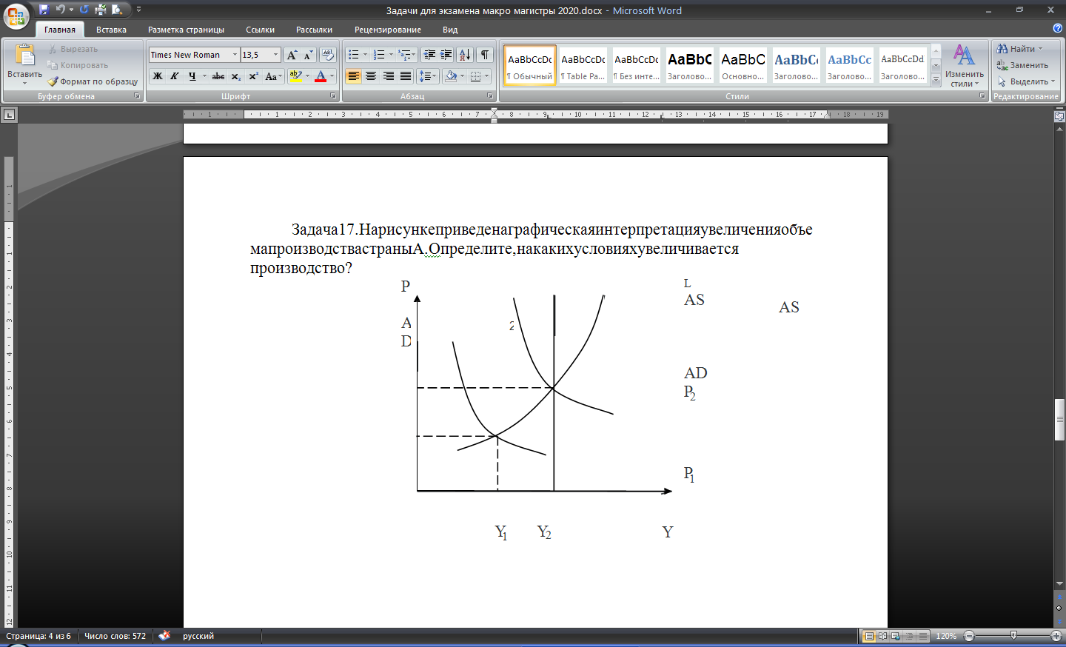

Task 18.Determine the value of fixed assets in the following data (mln. Rub.): Buildings and structures - 50000; machinery and equipment - 13000; Instruments lasting more than a year - 17,000; computer equipment - 4000; materials and supplies - 6800; packaging and packing materials - 920.
Task 19.Determine the GDP calculated by production method: the market price of output - 2000; current material costs - 800; depreciation - 200; indirect taxes on goods and services - 300; government subsidies for their production - 200.
Task 20.Expected rate of return on investment in real terms is 10%, the market interest rate - 12%, the annual rate of inflation - 10%. It will be carried out in the project investment?
Task 21.The number employed in the economy of the country is 88 million people, the number of unemployed = 12 million people..:
a) Calculate the rate of unemployment;
b) determine the number of employees; the number of unemployed; unemployment, if within a month lost their job 1 million. people, and 2 million. People of the unemployed have stopped looking for work.
Task 22.Government spending multiplier is 2. How will the GDP with an increase in government spending by 200 thousand. Rub.?
Task 23.Dealer acquired on the stock exchange futures options on sale in two weeks 400 treasury bonds at the price of $ 280. Per piece. option value (the value of the premium paid) is $ 4,000 What action the dealer, if during this period the price of T-Bills had a minimum value.:
a) $ 285
b) $ 275
c) US $ 265?
Calculate the profit (loss) for the dealer in each case
Task 24.If the tax function of the form:T= 400 + 0,1Y, The function of social transfers -TR = 300-0,2 (Y-Yf), Government purchases are 250, the national debt - 100, and the percentage of payments on public debt - 10%. actual GDP 200 units lower potential level (Yf = 1000).
What is the primary budget deficit?
Task 25.The commercial bank has a deposit of 5,000 thousand. Den. u Reserve requirement - 20%. How much represented loans, at least, is capable of increasing the deposit if the reserve requirement drops to 15%.
Task 26.The X bank deposit has 6000 den. u Reserve requirement - 15%. This deposit is able to increase the amount of loans provided by at least ...
Task 27.The model is "AD-AS" long-term Asd curve is represented as Y = 4200. Short Ask curve represented at P = 12. The curve AD is given by the equation: Y = 2,5 · M / P, wherein the bid amounts of money 1680. As a result, Ask price shock curve up to the level of P = 19.
Define:
a) What are the coordinates of the point of short-term equilibrium, steady-state after the shock?
b) How much should increase the supply of money the central bank to set the initial level of output in the economy?

Associate Professor Rudenko E.V.

