МИНИСТЕРСТВО СЕЛЬСКОГО ХОЗЯЙСТВА
И ПРОДОВОЛЬСТВИЯ РЕСПУБЛИКИ БЕЛАРУСЬ

УЧРЕЖДЕНИЕ ОБРАЗОВАНИЯ
«ГРОДНЕНСКИЙ ГОСУДАРСТВЕННЫЙ
АГРАРНЫЙ УНИВЕРСИТЕТ»

Кафедра белорусского и иностранных языков

АНГЛИЙСКИЙ ЯЗЫК
РАБОЧАЯ ТЕТРАДЬ
для занятий по домашнему чтению
для студентов факультета ветеринарной медицины

Гродно 2019
УДК 811.111(076):619
ББК 81.2 Англ
А 64

Автор: О.И. Белова
Рецензент: А.И. Лещук

А 64 | Английский язык: рабочая тетрадь для занятий по домашнему чтению для студентов факультета ветеринарной медицины./  О.И. Белова. – Гродно: ГГАУ, 2019. – 67 с.

Рабочая тетрадь предназначена для студентов дневной и заочной форм обучения факультета ветеринарной медицины. Учебное пособие содержит тексты для чтения по специальности с комплексом упражнений, а также необходимый лексический минимум.

УДК 811.111.1(072)
ББК 81.2 Англ

Рекомендовано межфакультетской учебно-методической комиссией факультета защиты растений УО «ГГАУ» (Протокол № 9 от 30.05.19г.)
© УО «Гродненский государственный аграрный университет», 2019
© О.И. Белова, 2019

ВВЕДЕНИЕ

Рекомендуемое учебное пособие предназначено для аудиторной и внеаудиторной работы студентов факультета ветеринарной медицины.
Целью предлагаемого учебного пособия является подготовка студентов к самостоятельному чтению и пониманию оригинальной сельскохозяйственной литературы, ознакомление студентов с терминологией по данной специальности, обогащение словарного запаса в области изучаемой специальности, а также расширение профессионального кругозора.
Данное пособие включает в себя десять текстов на актуальные темы с заданиями для контроля понимания прочитанного, а также необходимый лексический минимум. Все тексты подобраны из оригинальной английской литературы или взяты со специализированных англоязычных сайтов. Упражнения дают возможность совершенствовать умения работы с англоязычным текстом, нахождения и анализ необходимой информации, и ее дальнейшее использование.
Чтение текстов по специальности на иностранном языке служит источником получения информации, а полученные навыки и умения научной обработки текстов (конспект, аннотирование, реферирование) делают возможным применение иностранных источников при овладении специальностью или способствуют профессиональному совершенствованию. Представленное учебно-методическое пособие направлено на решение данных задач.

UNIT 1. INTRODUCTION TO VETERINARY MEDICINE

VOCABULARY
treatment – лечение  livestock – домашний скот  domestication – одомашнивание  prevention – предотвращение, предупреждение  disease – болезнь  disorder – расстройство  deal with – иметь дело с, заниматься  transmit – передавать  susceptible – восприимчивый  veterinary surgeon – ветеринарный врач  preventive – профилактический, предупредительный  measure – мера  quarantine – карантин  sick – больной  spread – распространение  pasture – пастбище, пастись | eliminate – устранить  fertility – плодовитость  nutritional – пищевой  internal – внутренний  surgery – хирургия  wound treatment – обработка, лечение ран  fracture repair – лечение переломов  excision – удаление  obstetrics – акушерство  phenomena – явление, феномен  injury – рана, ушиб  hygiene – гигиена  illness – болезнь  animal husbandry – животноводствo  breeding – разведение

1. Match the words (1-6) with their definitions (A-F).

1. ____ obstetrics 4. ____ anesthesiology
2. ____ radiology 5. ____ diagnostics
3. ____ hygiene 6. ____ pharmacology

A. the science of drugs and their effect on living systems.
B. the care of pregnancy, the unborn baby, and the process of childbirth.
C. the science of using images (such as X-rays) to diagnose, treat and manage medical conditions and diseases.
D. the practice or principles of keeping animals and their environment clean in order to maintain health and prevent disease.
E. a series of medical tests designed to detect infections, conditions and diseases.
F. the field of medicine dedicated to relieving pain before, during, and after surgery.

2. Fill in the blanks with the correct words.
hygiene, surgery, diseases, immunization, susceptible,
radiology, pasture

1. Could you get the X-rays from ________ to see if the animal has any fractures.
2. Take this dog to __________ for its wound treatment.
3. The production of healthy poultry depends on the maintenance of ____________ in the poultry houses.
4. ____________ can prevent many diseases that cause lower productivity or death in cattle.
5. Animals raised on ____________ are usually much healthier and the food products they offer come with much more nutrients.
6. Animal ____________ pose a risk to public health and cause damage to farm businesses and the economy at large.
7. Highly ____________ animals are more likely to develop an illness because their immune system isn’t strong enough to withstand infection.

3. Write down Russian equivalents of these word combinations.
- treatment of livestock ____________________________
_________________________________________________
- take preventive and control measures _________________
_________________________________________________
- quarantine of sick animals _________________________
_________________________________________________
- proper pasture management __________________________
_______________________________________________________
- eliminate carriers of animal diseases ___________________
_________________________________________________
- the excision of body parts __________________________
_________________________________________________
- phenomena taking place in living organism ______________
_________________________________________________
- lower productivity ______________________________
_________________________________________________

4. Read the text. Pay attention to the words given above.

Introduction to Veterinary Medicine
Veterinary medicine was founded many thousand years ago. The word “veterinarius” is a Latin word. It means taking care of animals and treatment of livestock. The development of veterinary is connected with domestication of wild animals.
Veterinary Science is also called veterinary medicine and includes the prevention, diagnosis, and treatment of the diseases of domestic animals and dealing with other animal disorders. The field also deals with those diseases that can be transmitted from animals to humans.
Farm animals are susceptible to various infectious diseases and may suffer from viruses and harmful bacteria. That is why animals should be examined by veterinary surgeons regularly in order to notice disease symptoms in time and take the necessary preventive and control measures.
Vaccination and immunization, sanitary measures, and quarantine of sick animals should be used by farmers and veterinary surgeons to prevent the spread of infectious diseases. Sanitary control of animal housing and proper pasture management can eliminate many carriers of animal infectious diseases which can be easily transmitted by water and soil. Veterinary surgeons also treat parasitical infections, unsanitary conditions which may cause lower fertility in livestock and nutritional disorders.
A veterinary surgeon’s training must include the study of the basic preclinical disciplines of anatomy, histology, physiology, pharmacology, microbiology, bacteriology, virology, parasitology, and pathology. The clinical subjects of study may be divided into internal medicine, preventive medicine, surgery and clinical practice.

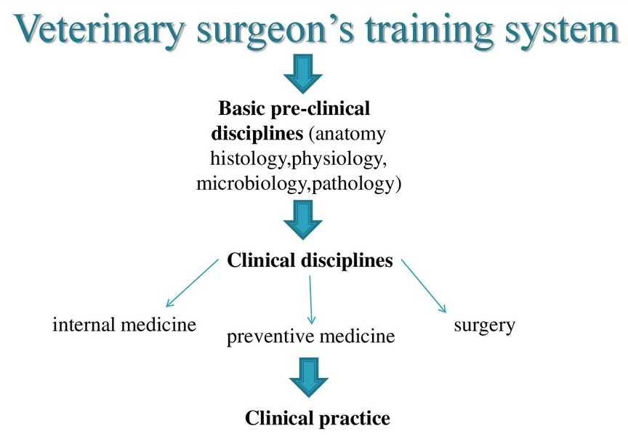
Internal medicine includes the diagnosis and treatment of diseases as they affect animals.
Preventive medicine should consider the aspects of disease prevention and control, especially such diseases that can be transmitted between animals and humans or diseases that may influence human health.
Surgery includes wound treatment, fracture repair, the excision of body parts and the use of such techniques as radiology, anesthesiology, obstetrics, etc.
Veterinary depends on several disciplines. Physiology is the study of the phenomena taking place in living organism. It is primarily a study of the function in the organs and the conditions which determine their function in the living animal. To know the structure of the animal body veterinarians study anatomy.
Veterinarians must get deep knowledge of biological chemistry because it is the basis of clinical laboratory diagnostics and therapy. Pharmacology is the scientific study of drugs and their use in the treatment of animal diseases and injuries. Hygiene is the practice of keeping animals and areas clean in order to prevent illness and disease.
Veterinary and animal husbandry are also closely connected with each other. Animal husbandry includes the breeding of farm animals and their use. It depends on veterinary medicine which helps to prevent many diseases causing lower productivity or death in cattle.

5. Find in the text and write out English equivalents of these word combinations.

- одомашнивание диких животных ____________________
_________________________________________________
- заметить симптомы болезни ______________________
_________________________________________________
- распространение инфекционных болезней ___________
_________________________________________________
- паразитарные инфекции ___________________________
_________________________________________________
- пищевые расстройства _____________________________
_________________________________________________
- доклинические дисциплины ________________________
_________________________________________________
- падёж скота _____________________________________

6. Complete the sentences according to the text.

1. The development of veterinary is connected _________________
_______________________________________________________.
2. Farm animals are susceptible to various _____________________
_______________________________________________________.
3. The clinical subjects of study may be divided ______________
____________________________________________________.
4. Surgery includes wound treatment, ______________________
___________________________________________________.
5. Pharmacology is the scientific study of __________________
___________________________________________________.
6. Animal husbandry depends on veterinary medicine which ___
___________________________________________________.

7. Answer the questions to the text.

1. When was veterinary founded? ____________________________
_______________________________________________________
2. What does veterinary science include? ______________________
_______________________________________________________
3. What must be controlled or prevented by veterinary surgeons? ___
_______________________________________________________
4. What measures should be taken to prevent infectious diseases? ___ _______________________________________________________
5. What must a veterinary surgeon’s training include? ____________
_______________________________________________________
6. What disciplines does veterinary depend on? _________________
_______________________________________________________
7. What does preventive medicine concern? ____________________
_______________________________________________________
8. Biological chemistry is the scientific study of drugs and their use, isn’t it? _________________________________________________
_______________________________________________________
9. What is animal husbandry? What science does it depend on? _______________________________________________________

UNIT 2. THE ORGANIZATION OF ANIMAL BODY
VOCABULARY
excrete – выделять  nutrition – питание  cell – клетка  tissue – ткань  muscle – мышца, мышечный  scattered – разбросаны  randomly – случайным образом  epithelial - эпителиальный  lining – оболочка  gland – железа  layer – слой  connective – соединительный  tendon – сухожилие  cartilage – хрящ  fibrous – волокнистый  spinal cord – спинной мозг  axon – аксон  backbone – позвоночник backbones (vertebrates) – позвоночные | trunk – туловище  limb – конечность  apparent – очевидный  mammals – млекопитающие  thorax (thoracic cavity) – грудная полость  abdomen (abdominal cavity) – брюшная полость  cavity – полость  dorsal – черепно-мозговая  enclose – окружать  cranial – черепно-мозговой  spinal – спинальный  digestive – пищеварительная  pelvic – тазовый  bladder – мочевой пузырь  cushion – создавать подушку  expand – расширяться

1. Match the words (1-6) with their definitions (A-F).

1. ____ abdominal cavity 4. ____ spinal cord
2. ____ trunk 5. ____ thoracic cavity
3. ____ dorsal cavity 6. ____ pelvic cavity

A. a thick cord of nerves inside your backbone which connects your brain to nerves in all parts of your body.
B. the part of the body that encloses digestive organs.
C. the part of the body that contains the bladder and reproductive organs.
D. the part of the body that encloses the brain and spinal cord.
E. a person's or animal's body apart from the limbs (конечности) and head.
F. the part of the body that contains the heart and lungs.

2. Fill in the blanks with the correct words.
enclosed, backbone, mammals, muscles, cell,
nutrition, expand

1. A ____________ injury is dangerous because it can damage the spinal cord.
2. ____________ are the only tissue in the body that has the ability to move the other parts of the body.
3. Internal organs are ____________ by certain body cavities.
4. A typical animal ____________ is about one-fifth the size of the smallest particle visible to the naked eye.
5. Humans are ____________ and so are dogs, whales, elephants, and horses.

6. Lungs are organs that ____________ to fill with air.
7. The proper ____________ of beef cattle is a key component of a successful beef production.

3. Write down Russian equivalents of these word combinations.
- main types of tissues in animals _______________________
_________________________________________________
- are scattered around randomly ______________________
_________________________________________________
- connective tissues _______________________________
_________________________________________________
- carry the nerve impulse _____________________________
________________________________________________
- less apparent features of vertebrates _________________
_________________________________________________
- a layer of muscle called the diaphragm __________________
_________________________________________________
- to cushion internal organs _________________________
_________________________________________________
- encloses most of the digestive organs ___________________
_________________________________________________

4. Read the text. Pay attention to the words given above.

The Organization of Animal Body
Living organisms move, feed, respire, grow, sense their environment, excrete and reproduce. These seven characteristics are sometimes summarized by the words “MRS GREN” functions of: Movement, Respiration, Sensitivity, Growth, Reproduction, Excretion, Nutrition.
Living organisms are made from cells which are organized into tissues and these are themselves combined to form organs and systems. Skin cells, muscle cells, skeleton cells and nerve cells, for example. These different types of cells are not just scattered around randomly but similar cells that perform the same function are arranged in groups. These collections of similar cells are known as tissues.
There are four main types of tissues in animals. The first is epithelial tissue that forms linings, coverings and glands. There are several different types of epithelium which have different shapes of the cells and consist of different number of layers of cells. Connective tissues are for transport and support, Blood, bone, tendons, cartilage, fibrous connective tissue and fat tissue are all classed as connective tissues. They are tissues that are used for supporting the body or transporting substances around the body.
Muscle tissues are for movement. They are composed of cells that contract and move the body. Nervous tissues are for carrying messages. Nervous tissue forms the nerves, spinal cord and brain. Nerve cells or neurons consist of a cell body and a long thread or axon that carries the nerve impulse.
It is well-known that the body of backbones (i.e. vertebrates) is divided into four sections. There is a head (that contains the brain, the major sense organs and the mouth), a trunk (that contains the other organs), the limbs and a well-developed tail. Other features of vertebrates may be less apparent. For instance, vertebrates that live on the land have developed a flexible neck that is absent in fish. Mammals but not other vertebrates have a layer of muscle called the diaphragm that divides the trunk into the chest or thorax and the abdomen.
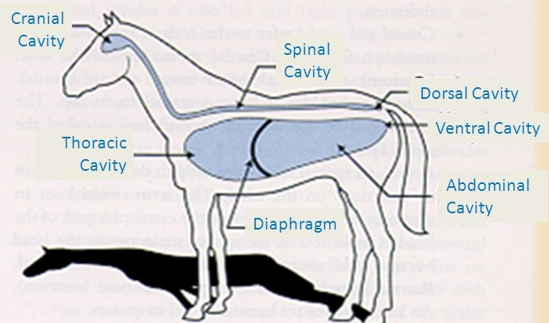

In contrast to many primitive animals, vertebrates have spaces or body cavities that contain the body organs. Most vertebrates have a single body cavity but mammals have four body cavities: (1) the dorsal cavity that encloses the brain and spinal cord and consists of cranial and spinal cavities; (2) the thoracic cavity (or chest) that encloses the heart and lungs; (3) the abdominal cavity that encloses most of the digestive organs and kidneys; and (4) the pelvic cavity that encloses the bladder and reproductive organs.
The cranial cavity cushions and protects the brain within a hard skull. The other body cavities also cushion internal organs, but instead of being hard, they have to be flexible because the heart, lungs, digestive organs, and reproductive organs can expand.

5. Find in the text and write out English equivalents of these word combinations.

- соединяются, формируя органы ____________________
_________________________________________________
- клетки, которые выполняют одну и ту же функцию ____
_________________________________________________
- образует оболочки, покрытия и железы ________________
_________________________________________________
- основные органы чувств____________________________
_________________________________________________
- гибкая шея, которая отсутствует у рыб _______________
_________________________________________________
- в отличие от многих примитивных животных __________
_________________________________________________
- репродуктивные органы могут расширяться ___________
_________________________________________________

6. Complete the sentences according to the text.

1. Living organisms are made from cells which are organized into __
____________________________________________________.
2. Connective tissues are used for supporting the body or ______
___________________________________________________.
3. Nerve cells or neurons consist of a cell body and __________
___________________________________________________.
4. The head contains the brain, the major __________________
___________________________________________________.
5. Vertebrates that live on the land have developed ___________
___________________________________________________.
6. In contrast to many primitive animals, vertebrates have ______
___________________________________________________.
7. The dorsal cavity encloses the brain and spinal cord and _______
___________________________________________________.

7. Answer the questions to the text.

1. What do the words “MRS GREN” functions mean? __________
____________________________________________________
2. How many main types of tissues are there? Name them. ______
____________________________________________________
3. What do muscle and nervous tissues serve for? ____________
____________________________________________________
4. What three sections is the body of backbones (i.e. vertebrates) divided into? _________________________________________
5. All the vertebrates have a layer of muscle called the diaphragm, don’t they? __________________________________________
6. Name the four body cavities of mammals. __________________
____________________________________________________
7. What are their functions? _____________________________
____________________________________________________

UNIT 3. BODY SYSTEMS

VOCABULARY

stomach – желудок  oesophagus – пищевод  intestine – кишечник, кишка  digestion – переваривание feather – перо  claw – коготь  hoof – копыто  joint – сустав  cardiovascular – сердечно-сосудистая  vessel – сосуд  fluid – жидкость  leak out – просачиваться  occur – происходить, иметь место  bronchiole – бронхиола | lungs – легкие  rib – ребро  digestive tube – пищеварительный тракт gland – железа  pancreas – поджелудочная железа  secretion – секреция, выделение  waste – отходы  urinary – мочевыделительный  kidney – почка  ureter – мочеточник  bladder – мочевой пузырь  response – реакция  tongue – язык  spinal cord – спинной мозг

1. Match the words (1-6) with their definitions (A-F).

1. ____ skin 4. ____ blood
2. ____ vessel 5. ____ tongue
3. ____ kidneys 6. ____ lungs

A. a body fluid in humans and other animals that delivers necessary substances to the cells and transports metabolic waste products away from those same cells.
B. a pair of spongy, air-filled organs located on either side of the chest.
C. The soft outer tissue covering of vertebrates with three main functions: protection, regulation, and sensation.
D. the fleshy muscular organ in the mouth of a mammal, used for tasting and swallowing.
E. two bean-shaped organs, located just below the rib cage, one on each side of your spine.
F. the part of the circulatory system that transports blood throughout the body.

2. Fill in the blanks with the correct words.
waste, hoof, digestion, response, stomachs,
occur, leaking out

1. __________ products from the digestive process include undigested parts of food, fluid, and older cells from the lining of the gastrointestinal tract.
2. Metabolism is the totality chemical reactions which _______ within a cell.
3. Cows can ferment plant-based food in a specialized stomach before the real process of__________.
4. One of the sheep diseases is the rot of the ________, which is an inflammation of the foot.

5. Scientists have found that protein can protect new blood vessels from __________.

6. Sheep also are ruminants, which means they have four __________ and chew cud (жуют жвачку).
7. The main type of __________ of the nervous system to stimuli is through muscle contraction, i.e. movements.

3. Write down Russian equivalents of these word combinations.
- to provide the stomach with the food ________________
_________________________________________________
- to transport substances around the body______________
_________________________________________________
- the fluid that leaks out of the blood vessels ___________
_________________________________________________
- processes that occur in the cell ____________________
________________________________________________
- muscles that move the ribs in breathing ______________
_________________________________________________
- to produce digestive secretions _____________________
_________________________________________________
- in both males and females _________________________
_________________________________________________
- the collection of glands that produce hormones _______
_________________________________________________

4. Read the text. Pay attention to the words given above.

Body Systems
Organs do not work in isolation but function in cooperation with other organs and body structures to keep an animal alive. For example the stomach can only work in cooperation with the mouth and oesophagus. They provide the stomach with the food which it breaks down and digests. It then needs to pass the food on to the intestines etc. for further digestion and absorption. These organs are collectively known as the digestive system.
There are eleven body systems. 1. The skin covering the body consists of two layers, the epidermis and dermis. Associated with these layers are hairs, feathers, claws, hoofs, glands and sense organs of the skin.
2. Skeletal System can be divided into the bones of the skeleton and the joints where the bones move over each other.
3. Muscular System. The muscles, in cooperation with the skeleton and joints, give the body the ability to move.
4. Cardiovascular System is also known as the circulatory system. It consists of the heart, the blood vessels and the blood. It transports substances around the body.
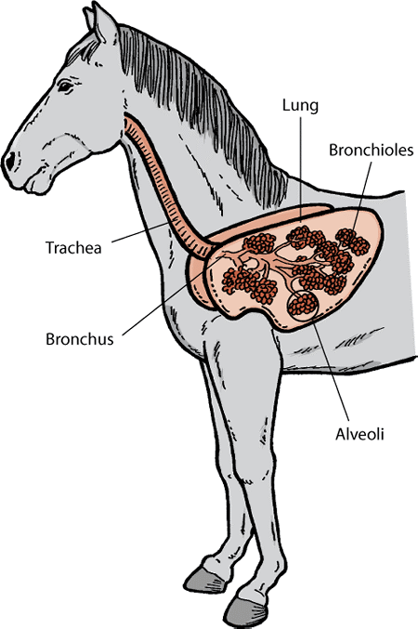
5. Lymphatic System is responsible for collecting and “cleaning” the fluid that leaks out of the blood vessels. This fluid is then returned to the blood system. The lymphatic system also makes antibodies that protect the body from invasion by bacteria etc.
6. Respiratory System. This is the system involved in bringing oxygen from the air into the body and getting rid of carbon dioxide, which is a waste product of processes that occur in the cell. It is made up of the trachea, bronchi, bronchioles, lungs, diaphragm, ribs and muscles that move the ribs in breathing.
7. Digestive System consists of the digestive tube and glands like the liver and pancreas that produce digestive secretions. It breaks down the large molecules of foods into smaller ones that can be absorbed into the blood and lymph. Waste material is also eliminated by the digestive system.
8. Urinary System removes waste products from the blood and is made up of the kidneys, ureters and bladder.
9. Reproductive System is a collection of internal and external organs – in both males and females – that work together for the purpose of making new individuals. Due to its vital role in the survival of the species, many scientists argue that the reproductive system is among the most important systems in the entire body.
10. Nervous System coordinates the activities of the body and responses to the environment. It consists of the sense organs (eye, ear, tongue and nose), the nerves, brain and spinal cord.
11. The Endocrine System is the collection of glands that produce hormones that regulate metabolism, growth and development, tissue function, sexual function, reproduction, sleep, and mood, among other things.

5. Find in the text and write out English equivalents of these word combinations.

- функционируют во взаимодействии с другими органами
_________________________________________________
- дальнейшее переваривание и поглощение ___________
_________________________________________________
- железы и органы чувств__________________________
_________________________________________________
- двигаются относительно друг друга ___________________
_________________________________________________
- сбор и очистка жидкости ___________________________
_________________________________________________
- избавление от углекислого газа ___________________
_________________________________________________
- важнейшая роль в выживании видов________________
_________________________________________________

6. Complete the sentences according to the text.

1. The skin covering the body consists of __________________
____________________________________________________.
2. The muscles, in cooperation with the skeleton and joints, ____
___________________________________________________.
3. The lymphatic system also makes antibodies that __________
___________________________________________________.
4. The digestive system breaks down the large molecules of foods __
___________________________________________________.
5. Many scientists argue that the reproductive system ___________
___________________________________________________.
6. Nervous system coordinates the activities ________________
___________________________________________________.
7. Glands produce hormones that regulate __________________
___________________________________________________.

7. Answer the questions to the text.

1. Do organs of the body work in isolation? ____________________
_______________________________________________________
2. How many body systems are there? Name them. _____________
_______________________________________________________
3. What layers does the skin covering the body consist of? ________
_______________________________________________________
4. What is the main function of the circulatory system? _________
_______________________________________________________
5. What is respiratory system made up of? _____________________
_______________________________________________________
6. Reproductive system is only characteristic of females, isn’t it? ___
_______________________________________________________
7. Does nervous system regulate metabolism? ________________
_______________________________________________________

8. Translate the words according to the meaning of the suffixes.

1. -itis – суффикс, обозначающий воспаление какого-либо органа, ткани и т.д. Например:
peritonitis – воспаление брюшины, перитонит
arthritis – _______________________________________
pancreatitis – _______________________________________
esophagitis – ________________________________________
bronchitis – _________________________________________
duodenitis – _________________________________________
nephritis – __________________________________________
hepatitis – __________________________________________
gastritis – ___________________________________________
meningitis – _________________________________________

2. -oma – суффикс, обозначающий опухоль. Например:
lymphoma – опухоль лимфатических узлов, лимфома.
osteoma – ______________________________________________

hepatoma – _____________________________________________

meningioma – ___________________________________________
lipoma – ________________________________________________
adenoma – ______________________________________________
angioma – ______________________________________________

3. –osis – суффикс, обозначающий заболевание, патологическое состояние. Например:
neurosis – общее заболевание нервной системы, невроз.
arthrosis – __________________________________________
nephrosis – __________________________________________
liposis – ____________________________________________
psychosis – __________________________________________

Notes:
arthron – сустав
duodenum – двенадцатиперстная кишка
nephra – почка
hepar – печень
gaster – желудок
meninges – мозговая оболочка
lipos – жир
aden – железа
angio – сосуд (преимущественно кровеносный)

UNIT 4. CIRCULATORY SYSTEM

VOCABULARY
arteriole – артериола  venula (venulae pl) – венула  vascular – сосудистый  opening – отверстие  vessel – сосуд  atrium (atria pl) – предсердие  ventricle – желудочек  septum – перегородка  anterior – передний  posterior – задний  vena cava – полая вена  pulmonary – легочный  fluid – жидкость  valve – клапан | involuntary – непроизвольный, рефлективный  extensible – растяжимый  collapse – сплющиваться  friction – трение  aorta – аорта  thoracic – грудной  abdominal – брюшной  capacity – ёмкость, объём  jugular – яремная вена (шейная)  liver – печень  spleen – селезенка  intestine – кишечник, кишка  pelvic – тазовый

1. Match the words (1-6) with their definitions (A-F).

1. ____ aorta 4. ____ artery
2. ____ vein 5. ____ arteriole
3. ____ vena cava 6. ____ venula

A. a small vein, especially one joining capillaries to larger veins.
B. the main artery of the body, supplying oxygenated blood to the circulatory system.
C. a blood vessel in the body that carries blood from the heart to the rest of the body.
D. a blood vessel in the body through which blood flows towards the heart.
E. a small branch of an artery leading into capillaries.
F. one of the two very large veins through which blood returns to the heart.

2. Fill in the blanks with the correct words.
valve, capacity, anterior, collapse, atria,
involuntary, vessels
1. A vast system of blood ________________ of a human – arteries, veins, and capillaries – is over 100,000 km long. That's long enough to go around the world more than twice!
2. The ____________ of the venous system is two or three times that of the arterial system.
3. The main function of a ________ is to keep blood moving in one direction.
4. There are two __________ in the heart – the left one connected to the lungs, and the right one connected to the venous circulation.

5. Unlike arteries, veins ________ when they are empty.
6. _________ movements are controlled by the autonomic nervous system. Among them are heartbeat and peristalsis (перистальтика).
7. There are two very large veins in the body ___________ vena cava and posterior vena cava.

3. Write down Russian equivalents of these word combinations.
- so-called vascular system _______________________
_________________________________________________
- two circulations, the greater and the lesser _____________
_________________________________________________
- the right and the left atria _________________________
_________________________________________________
- keeps the pure and impure blood from mixing __________ ________________________________________________
- involuntary, rhythmic contractions __________________
_________________________________________________
- blood distribution and pressure _____________________
_________________________________________________
- divides into thoracic and abdominal branches ___________
_________________________________________________
- conduct the blood back to the heart from the tissues ______
_______________________________________________
4. Read the text. Pay attention to the words given above.

Circulatory System
The circulatory organs consist of the heart, the arteries, the arterioles, the capillaries, the venulae, and the veins. Together they comprise the so-called vascular system. This system is a set of closed tubes beginning and ending at the heart and having only one or two openings. In the mammal there are two circulations, the greater and the lesser, each of which is provided with a heart.
The heart is the central organ of this system. It is attached at the base to the large blood vessels. The heart pumps the blood through the vessels by strong contractions of the powerful muscles. The average weight of the heart of the horse is 4-5 kg, of the pig – 300-480 g.
The heart has four cavities – the right and the left atria and the right and the left ventricles. The two cavities of one side are separated one from the other by a septum that keeps the pure and impure blood from mixing. They communicate one with another by valves which allow the blood to flow in one direction only, namely from the auricle to the ventricle.
The blood is kept in constant circulation through the vessels by the involuntary, rhythmic contractions of the heart which acts as a double pump. The right and left portions of the heart have no direct communication with each other. They work together but independently.
The term “arterial system” is given to the arteries as a whole. The arteries are the tubes that carry the blood from the heart to the tissue. Their walls are thick, strong, and contain much yellow, elastic tissue, which makes them extensible. When empty they do not collapse. Most arteries are straight in their course to reduce friction between the flowing blood and the walls of the arteries. Arteries communicate freely with one another, so blood distribution and pressure is the same everywhere.
One large vessel, the pulmonary artery, originates from the right ventricle and another, the aorta, from the left ventricle. These large arteries divide into smaller vessels and then in turn into yet smaller ones.
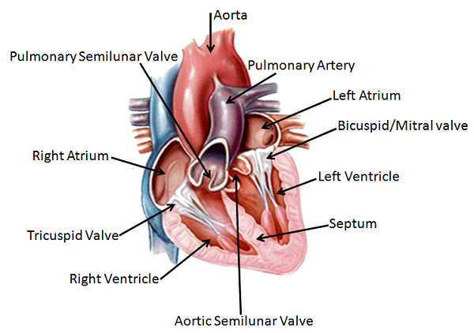
The pulmonary artery carries dark or venous blood from the right ventricle to the lungs, where it divides into numerous vessels that branch in the lung tissue. The aorta gives passage to the red or arterial blood from the left ventricle. This blood supplies all the organs of the body except the lungs. It is a short vessel that soon divides into thoracic and abdominal branches.
The capillaries are the tiny continuations of the arterioles that connect them with the venulae. The veins conduct the blood back to the heart from the tissues. The capacity of the venous system is two or three times that of the arterial.
The pulmonary veins carry to the left atrium the blood which has passed through the lungs and has become oxygenated. The anterior vena cava carries to the right atrium the blood returned from
the head and neck by the jugular veins and that from the thoracic limbs.
The posterior vena cava is the largest vein in the body and conveys to the right atrium nearly all the blood from the liver, spleen, intestines, other abdominal and pelvic organs, and the pelvic limbs.

5. Find in the text and write out English equivalents of these word combinations.

- при помощи сильных сокращений ________________
_________________________________________________
- позволяют крови течь только в одном направлении _____
_________________________________________________
- работают вместе, но независимо _____________________
_________________________________________________
- желтые эластичные ткани ___________________________
_________________________________________________
- пропускает красную, или артериальную, кровь ________
_________________________________________________
- крошечные продолжения артериол ___________________
_________________________________________________
- в два или три раза больше чем ____________________
_________________________________________________

6. Complete the sentences according to the text.

1. The circulatory organs consist of _______________________
____________________________________________________.
2. The heart pumps the blood through the vessels by __________
___________________________________________________.
3. The right and left portions of the heart have no ____________
___________________________________________________.
4. Most arteries are straight in their course to reduce___________
___________________________________________________.
5. Pulmonary artery and aorta divide into smaller vessels and then __
___________________________________________________.
6. The anterior vena cava carries to the right atrium ____________
___________________________________________________.
7. The posterior vena cava conveys to the right atrium __________
___________________________________________________.

7. Answer the questions to the text.

1. What is vascular system? ________________________________
_______________________________________________________
2. How many circulations are there in the mammal? Name them. __
_______________________________________________________
3. What cavities does the heart have? _________________________
_______________________________________________________
4. What is called arterial system? ___________________________
_______________________________________________________
5. Why is blood distribution and pressure the same along all the arteries? _____________________________________________
_______________________________________________________
6. What are the capillaries? ________________________________
_______________________________________________________
7. How does the capacity of the venous and arterial system compare? ___________________________________________
_______________________________________________________
8. What kind of blood do aorta and pulmonary artery carry? _______
_______________________________________________________

UNIT 5. THE ANATOMY OF THE BIRD
VOCABULARY
external – наружный, внешний  comb – гребень  beak – клюв  wattle – сережка (у птиц)  earlobe – мочка уха  eye ring – кольцо вокруг глаза  thigh – бедро  hock – пятка  shank – голень  spur – шпора | pouch – мешочек  crop – зоб  ventriculus – желудок, желудочек  gizzard – второй желудок  band – связка, пучок волокон  grit – песок, гравий  liquid – жидкость  lightweight – облегченный  withstand – выдерживать  take off – взлетать  jaw – челюсть
diffuse – распределять  claw – коготь  air sac – альвеолярный мешочек  bellows – мехá  maintain – поддерживать  volume – объём  four-chambered – четырехкамерный  nutrient – питательное вещество  papilla – сосок, сосочек, бугорок | hollow – полый  flexible neck – гибкая шея  fused – слитный, срощенный  breastbone – грудина  sternum – грудина  attachment – прикрепление, присоединение  keel – киль

1. Match the words (1-6) with their definitions (A-F).

1. ____ beak 4. ____ spur
2. ____ claw 5. ____ comb
3. ____ jaw 6. ____ wattle

A. one of the sharp curved nails at the end of each of the toes of some animals and birds.
B. the loose skin that hangs from the neck of some birds, such as a rooster or turkey.
C. the hard, poined part of a bird's mouth.
D. a fleshy crest (хохолок) on the head of the domestic chicken and other domestic birds.
E. a special part of the legs of some birds.
F. the upper and lower bony structures in vertebrates forming the framework of the mouth and containing the teeth.

2. Fill in the blanks with the correct words.
hollow, breastbone, jaw, volume, nutrient,
liquid, lightweight

1. In the average adult, the __________ of air taken into the lungs in a single breath is about 0.5 liters. However, the lungs can hold a total of about 4-6 liters.
2. The ___________ part of a bird bone isn't wasted space. In some bones, these cavities contain extensions of the air sacs from the lungs, which helps the bird to get the oxygen it needs quickly and easily.
3. Birds that obtain all their requirements in __________ from their food do not have to drink at all.
4. The skeletons of birds are _______________ as a result of selection for minimizing the energy required for flight.

5. Birds lack a true __________, and instead have a beak, which is far more lightweight. .
6. Poultry diets must provide all of the bird's ___________ requirements for optimum growth and production.
7. The ____________ is one of the largest bones of a bird's skeleton.

3. Write down Russian equivalents of these word combinations.

- basic external parts of a chicken _____________________
_________________________________________________
- to diffuse air throughout the bird's bloodstream ___________
_________________________________________________
- efficient nutrient and oxygen transport __________________
_________________________________________________
- muscular pouch along the esophagus __________ ________________________________________________
- to allow the liquid to flow by gravity __________________
_________________________________________________
- extremely lightweight but strong _____________________
_________________________________________________
- to withstand the stresses of taking off ________________
_________________________________________________
- an attachment site for the muscles used for flight _______
_________________________________________________

4. Read the text. Pay attention to the words given above.

The Anatomy of the Bird

The basic external parts of a chicken include the comb, beak, wattles, ears, earlobes, eyes, eye rings, wings, tail, thighs, hocks, shanks, spurs, claws, and toes. Both male and female chickens have these basic parts. The differences between males and females include the size of the comb and wattles and the size of the spurs (in older birds.
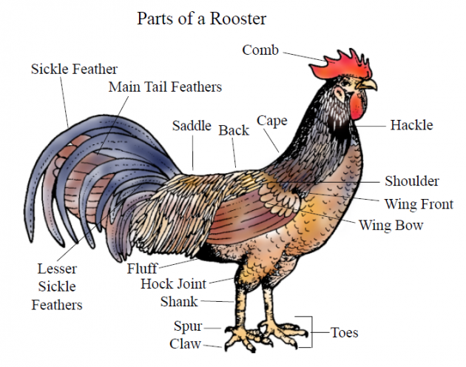
Birds are just as different from us on the inside as they are on the outside.
Respiratory system. Much like human lungs, avian lungs serve to diffuse air throughout the bird's bloodstream. They are unique, however, in the fact that they have small air sacs that allow air to flow through the lung in only one direction, ensuring a constant supply of fresh oxygen. These sacs store air and act like bellows, allowing the lungs to maintain a fixed volume with fresh air constantly flowing through them.
Circulatory system. Birds have a four-chambered heart. This adaptation allows for efficient nutrient and oxygen transport throughout the body. It provides birds with energy to fly and maintain high levels of activity. Because birds are high-energy animals, their hearts beat much faster than those of mammals. Some bird species have a resting heart rate of over 500 beats per minute!
Digestive system. The bird has sharp teeth-like structures in its mouth called papillae, which help birds to hold and move food around. Many birds have a muscular pouch along the esophagus called a crop.
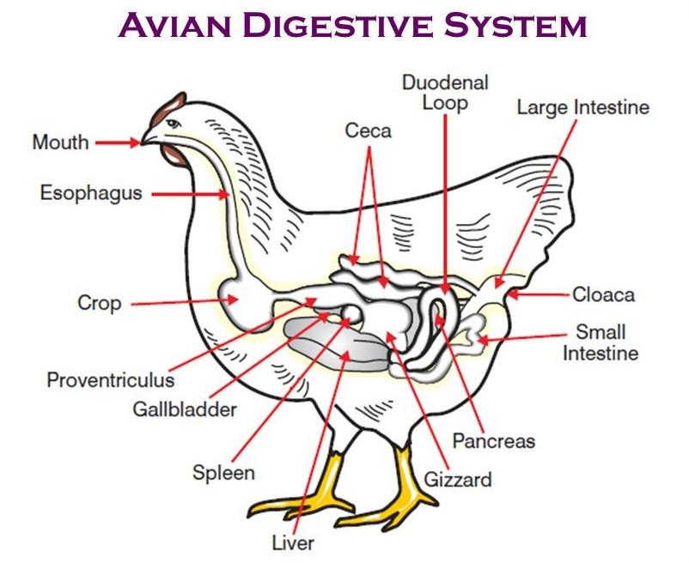
The crop functions to soften food and regulate its flow through the system by storing it temporarily. Birds have a ventriculus, or gizzard, composed of four muscular bands that rotate and crush food by shifting the food from one area to the next within the gizzard.
The gizzard of some species contains small pieces of grit or stone. It is swallowed by the bird to aid in the grinding process of digestion, serving the function of mammalian teeth. The use of gizzard stones is a similarity between birds and dinosaurs.
Drinking behavior. Most birds drink by repeatedly raising their heads after filling their mouths to allow the liquid to flow by gravity.
The bird skeleton is highly adapted for flight. It is extremely lightweight but strong enough to withstand the stresses of taking off, flying, and landing. Birds usually have a smaller number of bones than other vertebrates. Birds also lack teeth or even a true jaw, but they have a beak, which is far more lightweight. Birds have many bones that are hollow. Birds also have a highly flexible neck consisting of 13–25 vertebrae.
Birds are the only vertebrate animals to have a fused breastbone (or a sternum). The keel of the sternum serves as an attachment site for the muscles used for flight, or similarly for swimming in penguins. It is noted that swimming birds have a wide sternum, while walking birds had a long or high sternum while flying birds have the width and height nearly equal.

5. Find in the text and write out English equivalents of these word combinations.

- разница между самцами и самками ________________
_________________________________________________
- также как и легкие человека ______________________
_________________________________________________
- двигаться по легким только в одном направлении ______
_________________________________________________
- обеспечивать птиц энергией для полёта ______________
_________________________________________________
- частота сердцебиений в состоянии покоя ___________
_________________________________________________
- удерживать и продвигать пищу ___________________
_________________________________________________
- меньшее количество костей, чем у других позвоночных _
_________________________________________________

6. Complete the sentences according to the text.

1. The differences between males and females include ____________
____________________________________________________.
2. Avian lungs are unique in the fact that they __________________
___________________________________________________.
3. A four-chambered heart in birds allows for efficient ___________
___________________________________________________.
4. The bird has sharp teeth-like structures in its mouth called papillae, which______________________________________________ ___________________________________________________.
5. The use of gizzard stones is a similarity __________________
___________________________________________________.
6. Birds also lack teeth or even a true jaw, but _______________
___________________________________________________.
7. The keel of the sternum serves as an attachment site for the muscles ____________________________________________
___________________________________________________.

7. Answer the questions to the text.

1. What are the basic external parts of a chicken? ________________
_______________________________________________________
2. Are birds different from us on the inside or on the outside? _____
_______________________________________________________
3. What do avian lungs serve to? _____________________________
_______________________________________________________
4. Why do birds’ hearts beat much faster than those of mammals? ___
_______________________________________________________
5. What is the function of the crop? __________________________
_______________________________________________________
6. How do most birds drink? ________________________________
_______________________________________________________
7. How is the bird skeleton adapted for flight? __________________
_______________________________________________________
8. How does sternum vary in swimming, walking and flying birds?__
____________________________________________________
_______________________________________________________

UNIT 6. THE ANATOMY OF THE DOG
VOCABULARY
muzzle –морда  dewlap –подгрудок  wither –холка  forefoot – передняя конечность  croup – круп  hind foot – задняя конечность  sickle – серповидный  cork-screw – винтовой, спиралевидный  dock – купировать  fur coat – шёрстный покров  predatory – хищный  endurance – выносливость  sprint – бежать на короткую дистанцию  leap –прыжок, скачок; прыгать  chase –преследовать, гнаться  prey –добыча, охотиться  tight – крепкий | rigid – негибкий, негнущийся  torso – туловище  disconnected – несвязанный, изолированный, отдельный  stride – шаг  dewclaw – рудиментарный отросток в виде пальца на лапе  dichromatic – двухцветный  retina – сетчатка  field of vision – поле зрения  define – определять  frequency – частота  ultrasound – ультразвуковой  distinguish by ear – различать на слух  tilt – наклонять  canine –собачий

1. Match the words (1-6) with their definitions (A-F).

1. ____ canine 4. ____ wither
2. ____ dewclaw 5. ____ frequency
3. ____ prey 6. ____ predatory

A. animals preying naturally on others.
B. the number of sound waves per a period of time, for example per one second.
C. the ridge (хребет) between the shoulder blades of a four-legged animal, the standard place to measure the animal's height.
D. relating to or resembling a dog.
E. an animal that is hunted and killed by another for food.
F. a rudimentary toe present in some dogs.

2. Fill in the blanks with the correct words.
endurance, ultrasound, retina, chase, dichromatic,
muzzle, to dock

1. In the domestic dog the _________ begins just below the eyes, and includes the dog's nose and mouth.
2. Dogs are animals with great natural ____________. Their bodies are able to withstand long activities and to cover great distances when needed.
3. In 2006 it was banned to ____________ the dogs’ tales for cosmetic purposes in England and Wales.
4. Dogs are not completely color blind because they have a _____________ color perception.

5. ______________ echoes are used in medicine to build pictures of organs inside the body.
6. One of the reasons that dogs __________ their tail is boredom, especially in older dogs.
7. A variety of genetic and non-genetic factors may cause the separation of ______________ from the back of the eyeball.

3. Write down Russian equivalents of these word combinations.

- sickle, curled and cork-screw tails ____________________
_________________________________________________
- a variety of fur coats _____________________________
_________________________________________________
- in order to chase and catch the prey __________________
_________________________________________________
- a greater stride length for running and leaping _________
________________________________________________
- dichromatic color vision equivalent to red-green color blindness in humans _____________________________
_________________________________________________
- perfectly distinguish the sounds of music by ear _________
_________________________________________________
- tilt, rotate and raise or lower a dog's ear ________________
_________________________________________________
- compared to their canine relatives ___________________
_________________________________________________

4. Read the text. Pay attention to the words given above.

The Anatomy of the Dog
External anatomy of the dog study such organs as muzzle, dewlap (throat, neck skin), shoulder, elbow, withers, forefeet, croup, leg, hind feet, paws, tail.
Tail. There are many different shapes for dog tails: straight, straight up, sickle, curled, cork-screw. In some breeds, the tail is traditionally docked to avoid injuries. It can happen that some puppies are born with a short tail or no tail in some breeds.
Fur. Modern dog breeds have a variety of fur coats. There are dogs without fur at all and breeds with fur length as much as 55 cm. Dog coats also vary in texture and color.
Physical characteristics. Like most predatory mammals, the dog has powerful muscles, a cardiovascular system that supports endurance and sprinting. Its teeth are good for catching, holding, and tearing.
The dog's skeleton gives them the ability to run and leap in order to chase and catch the prey. So, they have small, tight feet and walk on their toes. Their hind feet are a little rigid and tight; the forefeet are flexible, and only muscle attach them to the torso.
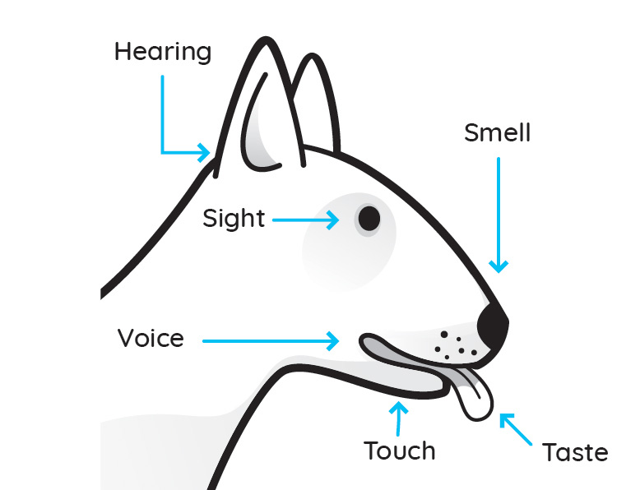
Dogs have disconnected shoulder bones that allow a greater stride length for running and leaping. They walk on four toes, front and back, and have dewclaws on their forefeet and sometimes on their hind feet.
Sight. Like most mammals, dogs have dichromatic color vision equivalent to red-green color blindness in humans. Different breeds of dogs have different eye shapes and sizes, and they also have different forms of retina.
Dog’s field of vision is different from those of man. Our field of vision has the shape of a circle, and that of dog is more oval. So, some breeds have a field of vision up to 250°, which is 60-70° more than in humans. However, breeds with short noses have a much narrower field of vision, as low as 180°.
Dogs have excellent night vision, which is 3-4 times as good as human night vision.
Hearing. Dogs’ ears are much more sensitive than ours. We can define sound frequency up to 20 kilohertz (kHz), and dogs – up to 40 kHz, which is ultrasound for our ear. Dogs perfectly distinguish the sounds of music by ear.
In addition they have a degree of ear mobility that helps them rapidly define the exact location of a sound. Additionally, a dog can identify a sound's location much faster than a human can, as well as hear sounds up to four times the distance that humans are able to. Eighteen or more muscles can tilt, rotate and raise or lower a dog's ear.
Smell. Dogs have nearly 220 million smell-sensitive cells over an area about the size of a pocket handkerchief. Dogs can sense smell at concentrations nearly 100 million times lower than humans can. The percentage of the dog's brain that analyse smells is 40 times larger than that of a human. Some dog breeds have been selectively bred for excellence in detecting smells, even compared to their canine relatives.

5. Find in the text and write out English equivalents of these word combinations.
- купируется, чтобы избежать травм ________________
_________________________________________________
- поддерживает выносливость и способность быстро бегать ________________________________________
_________________________________________________
- имеют рудиментарный отросток в виде пальца на передней лапе _________________________________
_________________________________________________
- определять звук частотой вплоть до ______________
_________________________________________________
- некоторая степень подвижности уха _______________
_________________________________________________
- размером с носовой платок ______________________
_________________________________________________
- выводились ради максимальной эффективности в определении запахов ___________________________
_________________________________________________

6. Complete the sentences according to the text.

1. Some puppies are born with __________________________
____________________________________________________.
2. Dog’s teeth are good for ______________________________
___________________________________________________.
3. Their hind feet are a little rigid and tight; _________________
___________________________________________________.
4. Our field of vision has the shape of a circle, and ______________ ___________________________________________________.
5. Dogs have excellent night vision, which __________________
___________________________________________________.
6. Dogs have a degree of ear mobility that helps _______________
___________________________________________________.
7. The percentage of the dog's brain that analyse smells __________
___________________________________________________.

7. Answer the questions to the text.

1. What organs does external anatomy of the dog study? __________
_______________________________________________________
2. What features of the dog's skeleton gives them the ability to run and leap? ___________________________________________
_______________________________________________________
3. Is dog’s vision the same as human vision? ___________________
_______________________________________________________
4. What is dichromatic color vision equivalent to? _______________
_______________________________________________________
5. Do all the breeds have the same field of vision? _______________
_______________________________________________________
6. What is the speed and distance of identifying location of the sound in dogs? _______________________________________________
_______________________________________________________
7. What concentrations smell can dogs sense? __________________
_______________________________________________________
8. What have some dog breeds been selectively bred for? ______
____________________________________________________

UNIT 7. THE ANATOMY OF THE HORSE
VOCABULARY
equine – лошадиный  equid – непарнокопытное животное  grazing – пастбищный  palate – нёбо  cardiac sphincter – кардиальный сфинктер  capacity – вместимость  chyme – химус, пищевая кашица  mare – кобыла  gestation – беременность  mating – спаривание  fallopian tubes – фаллопиевы трубы  oviduct – яйцевод  ovum – яйцеклетка зрелая  ovary – яичник  uterus – матка  cilia – ресница, ресничка  mammary gland – молочная железа  duct – проток  stallion – жеребец  crest – грива  framework – основа, каркас, рамки  appendicular skeleton – добавочный скелет | axial skeleton – осевой скелет vertebral column – позвоночный столб  sternum – грудина, грудная кость  forefoot – передняя конечность  hind foot – задняя конечность  limb – конечность  tendon – сухожилие  ligament – связка  fibrous – волокнистый  heal – излечивать, способствовать заживлению  сhord – хорда, струна  cartilage – хрящ  flexor – флексор, мышца-сгибатель  extensor [iks'tensə] – разгибатель, мышца-экстензор  tendonitis – тендинит, воспаление сухожилия  pharynx – глотка  larynx – гортань  monocular vision – монокулярное зрение  pinna, (pl.pinnae) – наружное ухо

1. Match the words (1-6) with their definitions (A-F).

1. ____ stallion 4. ____ axial skeleton
2. ____ mare 5. ____ tendon
3. ____ appendicular skeleton 6. ____ ligament

A. a short band of flexible fibrous tissue which connects two bones or cartilages or holds together a joint.
B. an uncastrated male horse; a male horse kept for breeding.
C. the part of the skeleton that consists of the bones of the head and trunk of a vertebrate.
D. the portion of the skeleton of vertebrates consisting of the bones that support the limbs. .
E. a flexible but inelastic cord of strong fibrous collagen tissue attaching a muscle to a bone.
F. the female of a horse or other equine animal.

2. Fill in the blanks with the correct words.
grazing, framework, equids, mammary gland, limbs,
heal, pharynx

1. Apart from domestic horses and donkeys, the horse family, also known as _________, comprises six wild species of donkeys and zebras.
2. Communication with horses may __________ some psychological disorders, and this equine therapy is widely used in many countries.
3. The skeletal system provides the strong __________ for the support and protection of the organs and systems of the animal body.
4. The part of the throat behind the mouth and nasal cavity is called __________.

5. _________ animals can be an important factor in maintaining balanced and diverse ecosystems.
6. The horse has two ______________, which are quite small, unlike the cow (which has four).
7. The _________ of the horse are structures made of dozens of bones, joints, muscles, tendons and ligaments that support the weight of the equine body.

3. Write down Russian equivalents of these word combinations.

- feed that a horse can take in at one time ________________
_________________________________________________
- controlling gestation, birth, lactation, and mating behavior __
_________________________________________________
- are divided into the appendicular skeleton and the axial skeleton _______________________________________
_________________________________________________
- fibrous material that is generally quite strong __________
________________________________________________
- are classified as flexors or extensors ___________________
_________________________________________________
- the availability of nutrients and oxygen to the tendon _____
_________________________________________________
- the largest eye of all land mammals __________________
_________________________________________________
- rotate in any direction to pick up sounds _______________
_________________________________________________

4. Read the text. Pay attention to the words given above.

The Anatomy of the Horse
Equine anatomy is the anatomy of horses and other equids, including donkeys, and zebras.
Digestive system. Horses are grazing animals, adapted to eating small amounts of the same kind of food all day long. The digestive system of a horse is about 30 m long, and most of this is intestines.
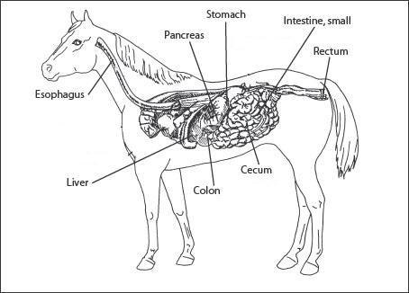
Digestion begins in the mouth, which is also called the “oral cavity”. It is made up of the teeth, the hard palate, the soft palate, the tongue and related muscles, the cheeks and the lips.
The esophagus is about 4–5 feet in length, and carries food to the stomach. A muscular ring, called the cardiac sphincter, connects the stomach to the esophagus. This sphincter is very well developed in horses.
Horses have a relatively small stomach for their size, and this limits the amount of feed that a horse can take in at one time. The horse has a stomach with a capacity of only 16-30 litres, and it works best when it contains 8-15 litres. In the stomach the food is broken down into chyme. It then leaves the stomach into the intestine.
Reproductive system. The reproductive system of the mare is responsible for controlling gestation, birth, lactation, and mating behavior of the mare. The mare has two ovaries, usually 7–8 cm in length and 3–4 cm thick that generally tend to decrease in size as the mare ages. The ovaries connect to the fallopian tubes (oviducts), which serve to move the ovum from the ovary to the uterus. To do so, the oviducts are lined with a layer of cilia, which produce a current that flows toward the uterus.
The mare has two mammary glands, which are smaller in younger mares. They have two ducts each, which open externally. The reproductive system of the stallion is responsible for the sexual behavior and secondary sex characteristics (such as a large crest) of the stallion.
Skeletal system. The skeleton of the horse has three major functions in the body. It protects vital organs, provides framework, and supports soft parts of the body. Horses have 205 bones, which are divided into the appendicular skeleton (the legs) and the axial skeleton (the skull, vertebral column, sternum, and ribs). Both forefeet and hind feet contain the same number of bones, 20 bones per limb. Bones are connected to muscles via tendons and other bones via ligaments. Bones are also used to store minerals, and are the place where red blood cells are formed.
Ligaments. Ligaments attach bone to bone or bone to tendon, and are vital in stabilizing joints as well as supporting structures. They are made up of fibrous material that is generally quite strong. Due to their relatively poor blood supply, ligament injuries generally take a long time to heal.
Tendons. Tendons are сhords of connective tissue attaching muscle to bone, cartilage or other tendons. They are necessary for support of the horse’s body, and translate the force generated by muscles into movement. Tendons are classified as flexors or extensors.
Tendinitis is most commonly seen in sport horses that gallop or jump. When a tendon is damaged the healing process is slow because tendons have a poor blood supply, reducing the availability of nutrients and oxygen to the tendon.
Respiratory system. The horse's respiratory system consists of the nostrils, pharynx, larynx, trachea, diaphragm, and lungs. The horse's respiratory system not only allows the animal to breathe, but also is important in the horse's sense of smell as well as in communicating.
Circulatory system. The horse's circulatory system includes the four-chambered heart, as well as the blood and blood vessels. Its main purpose is to circulate blood throughout the body to deliver oxygen and nutrients to tissues, and to remove waste from these tissues.
Eyes. The horse has the largest eye of all land mammals. It provides the horse with a wide field of monocular vision (in which both eyes are used separately), as well as good visual acuity and some ability to see color.
Hearing. The pinna of a horse's ears can rotate in any direction to pick up sounds. The hearing of horses is good, superior to that of humans, and the pinna of each ear can rotate up to 180°, giving the potential for 360° hearing without having to move the head. Often, the eye of the horse is looking in the same direction
as the ear is directed.

5. Find in the text and write out English equivalents of these word combinations.
- состоит из зубов и твердого и мягкого нёба ___________
_________________________________________________
- уменьшается в размерах по мере старения кобылы ____
_________________________________________________
- перемещать зрелую яйцеклетку из яичника в матку __
_________________________________________________
- вторичные половые признаки ____________________
_________________________________________________
- место, где образуются красные кровяные тельцá _______
_________________________________________________
- соединяют кость с костью или кость с сухожилием ______________________________________________
_________________________________________________
- преобразуют силу, производимую мышцами, в движение _____________________________________________
_________________________________________________

6. Complete the sentences according to the text.

1. Horses are grazing animals, adapted to ____________________
____________________________________________________.
2. Digestion begins in __________________________________
___________________________________________________.
3. Horses have a relatively small stomach for their size, and _______
___________________________________________________.
4. The reproductive system of the stallion is responsible for _______ ___________________________________________________.
5. Tendinitis is most commonly seen in _____________________
___________________________________________________.
6. The horse's respiratory system is also important in the horse's ___
___________________________________________________.
7. The horse’s eye provides the horse with a wide field of _________
___________________________________________________.

7. Answer the questions to the text.
1. What is equine anatomy? ________________________________
_______________________________________________________
2. What is oral cavity of the horse made up of? ________________
_______________________________________________________
3. Horses have a big stomach for their size, don’t they? ___________
_______________________________________________________
4. What are the major functions of the horse’s skeleton? __________
_______________________________________________________
5. Is the healing process in damaged tendons and ligaments in horses slow or fast? Why? ___________________________________
_______________________________________________________
6. What does the horse's respiratory system consist of ? __________
_______________________________________________________
7. What does the horse's circulatory system include? ____________
_______________________________________________________
8. How good is the hearing of horses? _____________________
____________________________________________________
UNIT 8. ANIMAL DISEASES THAT THREATEN MAN

VOCABULARY
transmit – передавать  zoonosis – зооноз  rabies – бешенство  bite – укус, кусать  saliva – слюна  wound – рана  tingling – покалывание  violent – самопроизвольный  contract – приобретать, подхватывать (болезнь и тп)  rural – сельский, деревенский  unvaccinated – невакцинированный  roaming – бродячий  brucellosis – бруцеллез  carcass – тело, туша  slaughter – убой скота  profuse sweating – обильное потоотделение  undulant fever – мальтийская лихорадка  undulant – волнообразный  bovine – бычий  tuberculosis – туберкулез  elimination – уничтожение | pasteurization – пастеризация  consume – потреблять  trichinosis – трихинеллез  pork – свинина  vomiting – рвота  poultry – домашняя птица  contaminated – заражённый  gastro-intenstinal – желудочно-кишечный  distres – расстройство  tetanus – столбняк  spore – спора  fecal – каловый, фекальный  leptospirosis – лептоспироз  urine – моча  eradicate – искоренять, уничтожать  threaten – грозить, угрожать  guard – защищать  quarter – помещение, место, стойло  parasite – паразит  quarantine – подвергать карантину

1. Match the words (1-6) with their definitions (A-F).

1. ____ zoonosis 4. ____ pasteurization
2. ____ parasite 5. ____ rural
3. ____ slaughter 6. ____ wound

A. relating to, or characteristic of the countryside not the town.
B. an injury to living tissue caused by a cut, blow, or other impact, typically one in which the skin is cut or broken.
C. an organism that lives in or on an organism of another species and gets nutrients at the other's expense.
D. the killing of animals for food.
E. the partial sterilization of a product, such as milk or wine, to make it safe for consumption and improve its keeping quality.
F. a disease which can be transmitted to humans from animals.

2. Fill in the blanks with the correct words.

saliva, transmit, contaminated, bites, unvaccinated,
rabies, consume

1. Globally, dogs are the most common animal infecting people with ______________.
2. Bacteria and viruses in the ______________ of an animal can be spread to a person in the result of a bite.
3. Most of the diseases caused by food come from contact with _________________ raw meat.
4. Some US states banned ______________ children to visit all public spaces for 30 days after the largest measles (корь) outbreak in the country for many decades.

5. Pets provide many benefits to humans. They comfort us and they give us companionship. However, some animals can also ___________ diseases to people.
6. The vast majority of milk that we __________ is pasteurized – heat-treated to kill off harmful pathogens.
7. More than 99% of the cases of rabies are the direct result of dog ___________.

3. Write down Russian equivalents of these word combinations.

- diseases, transmitted between animals and man ___________
_________________________________________________
- tingling at the place of the bite _____________________
_________________________________________________
- the time period between contracting the disease and the start of symptoms ______________________________________
_________________________________________________
- many roaming unvaccinated dogs and cats ____________
________________________________________________
- from carcasses at the time of slaughter __________________
_________________________________________________
- the undulant character of the fever, rising and falling like a wave _________________________________________
_________________________________________________
- serious testing and elimination of infected animals _______
_________________________________________________
- keep animal quarters clean ________________________
_________________________________________________

4. Read the text. Pay attention to the words given above.

Animal Diseases That Threaten Man
Animals, domesticated or wild, can be a source of human illness. Such diseases, transmitted between animals and man, are often called zoonoses.
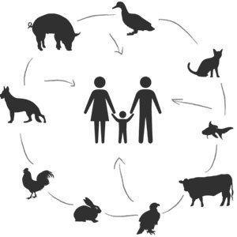
The animal disease that causes the most fear is rabies, a virus that attacks the nervous system. Early symptoms can include fever and tingling at the place of the bite. These symptoms are followed by one or more of the following symptoms: violent movements, uncontrolled excitement, fear of water, an inability to move parts of the body. Once symptoms appear, the result is nearly always death. The time period between contracting the disease and the start of symptoms is usually one to three months.
It is spread when an infected animal scratches or bites another animal or human. The saliva of an infected animal contains the deadly virus and comes to us through a bite or open wound. Rural people are at greater risk because of the proximity of wild animals, and urban people are at risk because of many roaming unvaccinated dogs and cats.
Another disease that can be transmitted from infected animals to man is brucellosis. Brucellosis infects cattle, goats and swine. It can be transmitted through raw milk, contract of an open wound or from carcasses at the time of slaughter. Symptoms include profuse sweating and joint and muscle pain.
Undulant fever is a severe disease that causes rising and falling fevers, sweating, weakness, headache, muscle pain and back pain. The disease is called so because of the undulant character of the fever, rising and falling like a wave. It can be avoided through good sanitation and management. Animals should be tested regularly and removed if infected.
Bovine tuberculosis is much less common today due to serious testing and elimination of infected animals. Protective measures are regular testing and slaughter of the animals showing positive reaction, and pasteurization of consumed milk.
Trichinosis is a painful and sometimes fatal disease in man. During the initial infection, it can result in diarrhea, abdominal pain, and vomiting. Eating uncooked or partially cooked infected pork is how we get in. Thorough cooking of pork is the best prevention.
Salmonella organisms are found in a variety of domestic and wild animals and poultry. Transmission to people occurs through contaminated food and water. The disease causes severe gastro-intestinal distress, fever and loss of appetite, and can be serious for the very young or old.
The natural reservoir of tetanus organisms is the intestinal tract of animals, especially horses. The spores are introduced into a person’s body by contamination of a wound with soil, street dust or fecal material. Tetanus is a horrible disease with a high fatality rate; therefore, all people should be immunized.
Leptospirosis in humans can be a serious disease. Carriers include domestic animals, rats and wild rodents. It is passed from animal to animal or to people through contact with infected urine, or with soil, feed, water or other materials so contaminated. Once on a farm, the disease is difficult to eradicate.
Tularemia is usually carried by wild rabbits and eating imperfectly cooked contaminated meat. Though the disease is not usually life threatening, it is characterized by a high fever.
Here are a few general preventive measures. Keep animal quarters clean. Immunize animals and keep them free of parasites. Quarantine or remove sick animals. Wear rubber gloves when treating sick animals or assisting at birth and if you have open wounds on your hands and arms. Wash up and change clothing when finished. Call your doctor if you become ill after contact with animals.

5. Find in the text and write out English equivalents of these word combinations.

- болезнь, которая вызывает больше всего страхов _______
_________________________________________________
- как только симптомы появляются _________________
_________________________________________________
- из-за близости диких животных ___________________
_________________________________________________
- обильное потоотделение и боль в мышцах и суставах _
_________________________________________________
- менее распространена сегодня _____________________
_________________________________________________
- происходит через загрязненную пищу и воду _______
_________________________________________________
- ужасная болезнь с высокой смертностью ____________
_________________________________________________

6. Complete the sentences according to the text.

1. Rabies is spread when an infected animal ___________________
____________________________________________________.
2. Urban people are at risk because of many __________________
___________________________________________________.
3. Bovine tuberculosis is much less common today due to _______
___________________________________________________.
4. Tetanus is a horrible disease with _____________________ ___________________________________________________.
5. Once on a farm, leptospirosis is ________________________
___________________________________________________.
6. Tularemia is usually carried by ________________________
___________________________________________________.
7. The horse’s eye provides the horse with a wide field of _________
___________________________________________________.

7. Answer the questions to the text.

1. What do we call diseases, transmitted between animals and man? _
_______________________________________________________
2. How can brucellosis be transmitted? _____________________
_______________________________________________________
3. Why is undulant fever called so? _______________________
_______________________________________________________
4. What is the natural reservoir of tetanus organisms? __________
_______________________________________________________
5. How can leptospirosis be transmitted? ____________________
_______________________________________________________
6. Is tularemia a life threatening disease? ___________________
_______________________________________________________
7. What are general preventive measures against zoonoses? _______
_______________________________________________________

UNIT 9. BIRD FLU (AVIAN INFLUENZA)

VOCABULARY
bird flu – птичий грипп  conventional influenza – обычный грипп  fever – лихорадка, жар  cough – кашель  sore throat – боль в горле, ангина  muscle ache боль в мышцах  strain– штамм  vary – варьироваться, меняться  ruffled – взъерошенный  feather – перо  severe – тяжелый, серьёзный  mortality смертность  susceptible – восприимчивый  appear – появляться, возникать  death – смерть  illness – болезнь  conjunctivitis – коньюктивит  resemble – быть похожим на  migratory – мигрирующие  waterfowl – водяные птицы  host – животное хозяин (источник) инфекции | turkey – индейка  goose (geese) – гусь (гуси)  bird-to-human transmission –передача от птицы к человеку  dropping – помет животных, навоз  nasal secretion – выделение носовой cекреции  domesticated – одомашнивание  poultry – домашняя птица  contaminated – зараженный  inhale – вдыхать  airborne – переносимый по воздуху  flock – стая (птиц)  cage – клетка (для животных)  destroy – уничтожать  survive – выживать  hotbed – очаг  outbreak – вспышка  wet market – открытый рынок продуктов  smuggle – провозить тайно, контрабандным путём

1. Match the words (1-6) with their definitions (A-F).

1. ____ fever 4. ____ susceptible
2. ____ cough 5. ____ hotbed
3. ____ mortality 6. ____ strain

A. a particular type of a virus.
B. the number of deaths in a given time or place.
C. likely to be influenced or harmed by an infection.
D. an abnormally high body temperature, usually accompanied by shivering and headache.
E. an environment promoting the growth of something, especially something unwelcome.
F. an act of expelling air from the lungs with a sudden sharp sound.

2. Fill in the blanks with the correct words.
airborne, outbreak, resemble, hosts, severe,
survive, flock

1. Until a _________ is tested, people may spread the disease without knowing that their birds are infected.
2. Many _____________ diseases affect humans. That is why understanding diseases that spread through the air, and how to prevent and avoid them, is important.
3. Flu viruses can ____________ in the air for several hours, especially at lower temperatures, and on hard surfaces they can remain infectious for 24 hours.
4. Influenza is a contagious respiratory illness caused by flu viruses. It can range from mild to _______________.

5. "Swine flu" is the popular name for flu caused by a relatively new type of flu virus responsible for a global flu ______________ (or pandemic) in 2009-10.
6. Symptoms of swine flu in men ____________ human influenza. Vaccine against human does not work against swine flu.
7. Birds are the natural ___________ of West Nile virus, which can cause a fatal neurological disease in humans.

3. Write down Russian equivalents of these word combinations.

- begins like conventional influenza __________________
_________________________________________________
- almost 100 percent mortality in susceptible species _______
_________________________________________________
- migratory waterfowl and ducks in particular ____________
_________________________________________________
- domesticated chickens, turkeys and geese ____________
________________________________________________
- direct bird-to-human transmission __________________
_________________________________________________
- contaminated water, feed or soil ______________________
_________________________________________________
- catch the disease by inhaling the airborne virus _________
_________________________________________________
- survive for long periods in cool temperatures _____________
_________________________________________________

4. Read the text. Pay attention to the words given above.
Bird Flu (Avian Influenza)
In people, bird flu usually begins like conventional influenza, with fever, cough, sore throat and muscle aches, but bird flu can lead to life threatening complications.
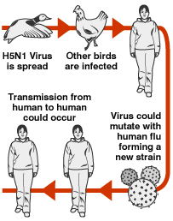
Bird flu viruses are complex, with a number of subtypes and strains that vary greatly from one another. Among birds, the effects of low pathogenic viruses are usually ruffled feathers or reduced egg production. But highly pathogenic forms cause severe disease, and almost 100 percent mortality in susceptible species. In some cases, domestic birds may die when symptoms appear.
Scientists still don’t know how these subtypes affect humans, but highly pathogenic viruses cause the most serious problems – the greatest number of deaths – in both people and animals. Although the exact incubation period for bird flu in humans isn't clear, illness is developed within one to five days.
Sometimes the only indication of the disease is a relatively mild eye infection (conjunctivitis). But more often, signs and symptoms of bird flu resemble those of conventional influenza, including: cough, fever, sore throat, muscle aches.
Migratory waterfowl and ducks in particular carry the viruses that cause bird flu. Often unaffected themselves, the host birds can spread the infection to susceptible species, especially domesticated chickens, turkeys and geese, resulting in severe epidemics that kill large numbers of birds – sometimes in a single day.
Direct bird-to-human transmission works like this: infected migratory waterfowl carry bird flu viruses, leave the virus in their droppings, saliva and nasal secretions. Domestic poultry become infected from contact with these birds or with contaminated water, feed or soil. They may also catch the disease by inhaling the airborne virus. Bird flu spreads quickly and lethally within a flock and is transported from farm to farm on tractors and other equipment, on cages, and on workers' shoes and clothing.
Heat destroys the virus, but it can survive for long periods in cool temperatures. Open-air markets, where eggs and birds are often sold in crowded and unsanitary conditions, are hotbeds of infection and spread the disease into the wider community.
Some scientists don't think that migratory birds are carrying the virus from continent to continent because outbreaks haven't followed traditional flyways. Instead, outbreaks seem much more likely to spread locally through “wet markets”, contaminated clothing and equipment, and smuggled birds.

5. Find in the text and write out English equivalents of these word combinations.
- привести к угрожающим жизни осложнениям _______
_________________________________________________
- снижение яйценоскости _________________________
_________________________________________________
- высокопатогенные вирусы _______________________
_________________________________________________
- хотя сами они часто могут оставаться незатронутыми ___
_________________________________________________
- единственный признак болезни _____________________
_________________________________________________
- распространяется быстро и со смертельным исходом __
_________________________________________________
- распространяют болезнь на широкий круг населения ___
_________________________________________________

6. Complete the sentences according to the text.

1. Bird flu viruses are complex, with a number of _______________
____________________________________________________.
2. Scientists still don’t know how these subtypes affect humans, but _
___________________________________________________.
3. Although the exact incubation period for bird flu ___________
___________________________________________________.
4. Sometimes the only indication of the disease is ______________ ___________________________________________________.
5. Often unaffected themselves, the host birds can spread the infection to __________________________________________
___________________________________________________.
6. Bird flu spreads quickly and lethally within _________________
___________________________________________________.
7. Heat destroys the virus, but it can _______________________
___________________________________________________.

7. Answer the questions to the text.

1. What are the symptoms of bird flu in people? _____________
_______________________________________________________
2. What are the effects of low pathogenic viruses among birds? ____
_______________________________________________________
3. Describe the effects of highly pathogenic viruses among birds? __
___________________________________________________
_______________________________________________________
4. Who carries the viruses that cause bird flu? _______________
_______________________________________________________
5. How does direct bird-to-human transmission work? ___________
_______________________________________________________
6. What are hotbeds of infection? _________________________
_______________________________________________________
7. Why don't some scientists think that migratory birds are carrying the virus from continent to continent? _____________________
_______________________________________________________

UNIT 10. PLAGUE OF DOGS

VOCABULARY
plague – чума  infectious – заразный  genus – род, вид  Yersinia pestis – чумнáя палочка  amaze – поражать  carrier – переносчик, носитель  squirrel – белка  hamster – хомяк  flea – блоха  rodent – грызун  feces – кал  contract – приобретать, подхватывать (болезнь и тп)  lymph nodes – лимфатические узлы  swelling – набухание, припухлость | inflammation – воспаление  swell (swelled, swollen) – набухать, разбухать  roam – бродить  pneumonic – легочный  septicemic – септический  vomiting – рвота  tonsil – миндалина  discharge – выделение  ulcer – язва  evaluation – оценка  sample – анализ, проба, образец  kidney – почка  liver – печень  establish – установить  definitive – окончательный  administer – назначать

1. Match the words (1-6) with their definitions (A-F).

1. ____ inflammation 4. ____ sample
2. ____ rodent 5. ____ pneumonic
3. ____ carrier 6. ____ septicemic

A. originated from the systemic infection of blood by pathogenic microorganisms, especially bacteria.
B. a small amount of a substance that a doctor or scientist collects in order to examine it.
C. a localized physical condition in which part of the body becomes red, swollen, hot, and often painful, especially as a reaction to injury or infection.
D. a host and transmitter of the cause of an infectious disease.
E. relating to, or affecting the lungs.
F. any of various small mammals with large sharp front teeth, such as mice and rats.

2. Fill in the blanks with the correct words.
genus, administered, infectious, swelling, roam,
plague, contracted

1. Sore lymph nodes can be caused by a variety of problems and may appear as ____________ in the neck and jaw area.
2. Scientists are developing new vaccines that could potentially protect against ____________ infection.
3. Veterinary medicines can be ______________ via various routes.
4. Wolves, dingos, dogs, coyotes and jackals are known as ____________ canis (волков).

5. Zoonotic diseases are ______________ diseases that are spread between animals and people.
6. A recent study of Australian veterinarians found that 44.9% of vets had ____________ an infection from an animal during their career.
7. Dogs that _________ the cities present a danger to other people, pets, and property, as well as themselves.

3. Write down Russian equivalents of these word combinations.

- amazes dogs of young age _________________________
_________________________________________________
- contract the disease if bitten by an infected flea ________
_________________________________________________
- bubonic plague, pneumonic plague, and septicemic plague __
_________________________________________________
- painfully swollen lymph nodes _____________________
________________________________________________
- the normal incubation period for bubonic plague _________
_________________________________________________
- run a full diagnostic evaluation on the dog ______________
_________________________________________________
- in order to establish a definitive diagnosis ______________
_________________________________________________
- to identify the presence of plague bacteria _____________
_________________________________________________

4. Read the text. Pay attention to the words given above.

Plague of Dogs
The plague of dogs is a bacterial infectious disease caused by the parasitic genus Yersinia pestis. It amazes dogs of young age, about one year. Carriers of this disease include rats, mice, squirrels, hamsters and in the fleas that feed on them. When a dog comes into touch with an infected rodent’s saliva, feces, or tissue, he becomes infected by Yersinia pestis. A dog may also contract the disease if bitten by an infected flea.
The infection travels rapidly to the lymph nodes, where white blood cells are produced. The resulting reaction from the lymph nodes is a rapid multiplication of white cells, abnormal fluid build-up with swelling, and possible skin breakage. Dogs infected with plague will experience fever, inflammation, and excessive pain because the lymph nodes are chronically swollen.
This disease is rare in dogs because they have a high resistance to the bacteria. However, there are no animals more susceptible to plague. Cats may also be infected with plague. Outdoor cats are most affected, and males predominate due to their tendency to roam.
Although it is quite rare, plague is transmittable to humans, and care should be taken to avoid fleas and body fluids from an animal that is suspected of being infected with the Yersinia bacterium.
There are three forms of plague: bubonic plague, pneumonic plague, and septicemic plague. Symptoms associated with bubonic plague will include painfully swollen lymph nodes, fever, inflammation, depression, vomiting, dehydration, diarrhea, enlarged tonsils, and anorexia. The head and neck area will swell considerably. Other symptoms include discharge from the eyes, mouth ulcers, and a loss of appetite, with visible weight loss. Coma may follow.
The normal incubation period for bubonic plague is between two and seven days after the dog has been bitten. In the case of pneumonic plague, a lung infection will occur; and with septicemic plague, the same symptoms as bubonic plague will appear, along with the infection of the blood.
To diagnose the plague veterinarian will run a full diagnostic evaluation on the dog, including blood samples, culture samples of fluids, and kidney and liver testing, in order to establish a definitive diagnosis of this disease. A swollen lymphatic system is a clear indication that infection is present. Blood tests will show the level of white blood cells present, amongst other things, which helps to identify the presence of plague bacteria.
A thorough physical examination will be undertaken to check for swelling around the neck and head, liver and kidneys, and to check for signs of dehydration, fever or lung infection.
Medication will be administered to treat the symptoms, and if plague is confirmed, or suspected, the dog will be isolated until the condition becomes better.

5. Find in the text and write out English equivalents of these word combinations.
- быстрое увеличение количества белых телец _______
_________________________________________________
- нет животных более восприимчивых к чуме __________
_________________________________________________
- из-за из склонности бродить _______________________
_________________________________________________
- хотя это бывает довольно редко __________________
_________________________________________________
- болезненно набухшие лимфатические узлы ___________
_________________________________________________
- наряду с заражением крови ______________________
_________________________________________________
- если чума подтверждается или подозревается _______
_________________________________________________

6. Complete the sentences according to the text.

1. A dog may also contract the disease if __________________
_____________________________________________________.
2. The resulting reaction from the lymph nodes is a rapid multiplication of ______________________________________
___________________________________________________.
3. This disease is rare in dogs because _____________________
___________________________________________________.
4. Symptoms associated with bubonic plague will include _______ ___________________________________________________.
5. In the case of pneumonic plague __________________________
___________________________________________________.
6. A swollen lymphatic system is a clear ____________________
___________________________________________________.
7. If plague is confirmed, or suspected, _______________________
___________________________________________________.

7. Answer the questions to the text.

1. What are the carriers of the plague of dogs? _______________
_______________________________________________________
2. What symptoms will dogs infected with plague experience? ____
_______________________________________________________
3. Name the animals most susceptible to plague? _____________
___________________________________________________
_______________________________________________________
4. Is plague transmittable to humans? ______________________
_______________________________________________________
5. What are three forms of plague? ________________________
_______________________________________________________
6. What diagnostic evaluation is necessary to diagnose the plague in dogs? _____________________________________________
_______________________________________________________
7. What can blood tests show amongst other things? _____________
_______________________________________________________

VOCABULARY
- abdomen [ˈabdəmən] (abdominal cavity) – брюшная полость
- administer [ədˈmɪnɪstə] – назначать (лекарство)
- animal husbandry [ˈanɪm(ə)l ˈhʌzbəndri] – животноводствo
- anterior [anˈtɪərɪə] передний
- aorta [eɪˈɔːtə] аорта
- atrium (atria pl) предсердие
- backbone – позвоночник
- backbones (vertebrates) – позвоночные
- bird flu ['bə:d 'flu:] птичий грипп
- bite [bait] – укус, кусать
- bovine ['bəuvain] – бычий
- breeding – разведение
- carcass ['ka:kəs] – тело, туша
- cardiovascular – сердечно-сосудистая
- carrier [ˈkarɪə] – переносчик, носитель
- cartilage ['ka:t(ə)liʤ] – хрящ
- cavity – полость
- cell – клетка
- consume [kən'sju:m] – потреблять
- contaminated [kəntimi'neitid] зараженный
- contract [ˈkɒntrækt] - приобретать, подхватывать (болезнь и тп)
- cough [kɒ:f] кашель
- deal with – иметь дело с, заниматься
- death ['ðeθ] смерть
- define – определять
- demestication – одомашнивание
- destroy [dis'trɒi] уничтожать
- digestion – переваривание
- digestive tube – пищеварительный тракт
- disease – болезнь
- disorder distres [distres] – расстройство
- domesticated [dɒmesti'keitid] одомашнивание
- eliminate eradicate [i'rædikeit] – устранить
- elimination [i'limi'nei∫ən] – уничтожение
- equid [ˈiːkwid] – непарнокопытное животное
- equine [ˈiːkwʌɪn] – лошадиный
- fertility – плодовитость
- fever ['fi:və] лихорадка, жар
- fibrous ['faibrəs] – волокнистый
- flock [flɒk] – стая (птиц)
- fluid – жидкость
- framework ['freimwə:k] – основа, каркас, рамки
- genus [ˈdʒiːnəs] – род, вид
- gestation [dʒɛˈsteɪʃ(ə)n] – беременность
- gland – железа
- heal [hi:l] – излечивать, способствовать заживлению
- hoof – копыто
- host [həʊst] – источник инфекции
- hotbed ['hɒtbed] очаг
- hygiene – гигиена
- illness ['ilnis] болезнь
- infectious [in'fek∫əs] заразный
- inflammation [ɪnfləˈmeɪʃ(ə)n] – воспаление
- inhale [in'heil] вдыхать
- injury – рана, ушиб
- intestine кишечник, кишка
- jaw – челюсть
- joint – сустав
- kidney [ˈkɪdni] – почка
- layer – слой
- ligament [ˈlɪɡəm(ə)nt] – связка
- limb – [lɪm] конечность
- lining – оболочка
- liquid – жидкость
- liver [ˈlɪvə] – печень
- livestock – домашний скот
- lungs – легкие
- mammals – млекопитающие
- measure – мера
- mortality [mɒ:`tæliti] смертность
- muscle – мышца, мышечный
- nutrient – питательное вещество
- nutrition – питание
- obstetrics – акушерство
- outbreak ['aυt'breik] вспышка
- plague ['pleig] чума
- pork [pɒ:k] – свинина
- poultry ['pəultri] – домашняя птица
- predatory [ˈprɛdət(ə)ri] – хищный
- prevention – предотвращение, предупреждение
- rabies ['reibiz] – бешенство
- response – реакция
- rodent [ˈrəʊd(ə)nt] – грызун
- sample [ˈsɑːmp(ə)l] – анализ, проба, образец
- slaughter ['slɒ:tə] – убой скота
- spread – распространение
- stomach – желудок
- strain [strein] – штамм
- susceptible [səˈsɛptɪb(ə)l] – восприимчивый
- tendon [ˈtɛndən] – сухожилие
- tissue – ткань
- transmit [trænz'mit] – передавать
- treatment – лечение
- vascular сосудистый
- vena cava полая вена
- ventricle желудочек
- veterinary surgeon – ветеринарный врач
- waste – отходы
- wound [wu:nd] – рана
- zoonosis [zu:'nəʊsis] – зооноз

CONTENTS
Введение……………………………………………………. | 3
Unit 1. Introduction to Veterinary Medicine ……………… | 4
Unit 2. The Organization of Animal Body ………………… | 10
Unit 3. Body Systems ………………………………………. | 14
Unit 4. Circulatory System ……………………………..…... | 18
Unit 5. The Anatomy of the Bird …………………..………... | 23
Unit 6. The Anatomy of the Dog ……………………………. | 27
Unit 7. The Anatomy of the Horse …………………………. | 33
Unit 8. Animal Diseases That Threaten Man ………………... | 39
Unit 9. Bird Flu (Avian Influenza) …………………………... | 45
Unit 10. Plague of Dogs ………………………………..….. | 50
Vocabulary…………………………………………………... | 61

Учебное издание

Белова Ольга Ивановна

РАБОЧАЯ ТЕТРАДЬ
для занятий по домашнему чтению
для студентов факультета ветеринарной медицины

Учебно-методическое пособие

Компьютерная верстка: О.И. Белова

Подписано в печать_________
Формат 60x84/16. Бумага офсетная. Гарнитура Таймс.
Печать Riso. Усл.печ.л.____ Уч.-изд.л.____
Тираж 50 экз. Заказ№_______

Учреждение образования
«Гродненский государственный аграрный университет»
Л.И № 02330/0548516 от 16.06.2009
230008, г. Гродно, ул. Терешковой, 28.

Отпечатано на технике издательско-полиграфического отдела
Учреждения образования «Гродненский государственный
аграрный университет».
230008, г. Гродно, ул. Терешковой, 28

